

**douze**

**onze**

**sept**



**8**

**neuf**

**9**

**10**

**12**

**11**

**7**

**dix**

**huit**



**deux**

**2**

**3**

**trois**

**4**

**cinq**

**six**

**6**

**5**

**1**

**quatre**

**un**

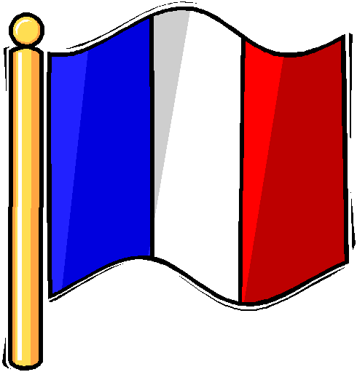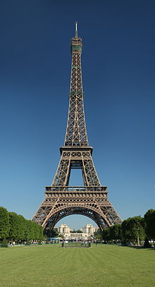

**Le Tricolore**

**La Tour Eiffel**

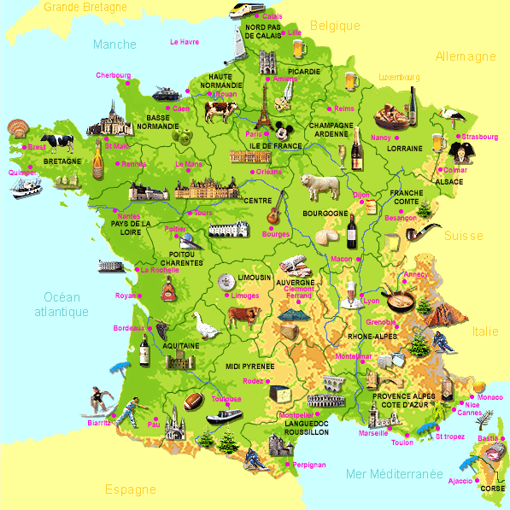

**La France**

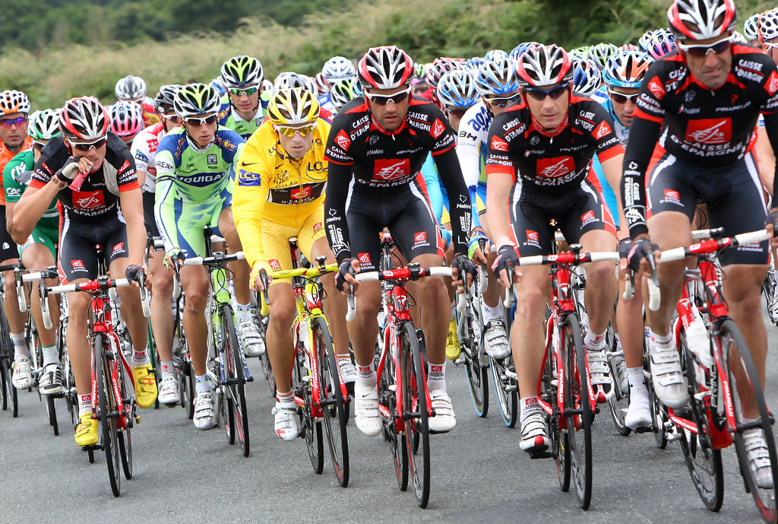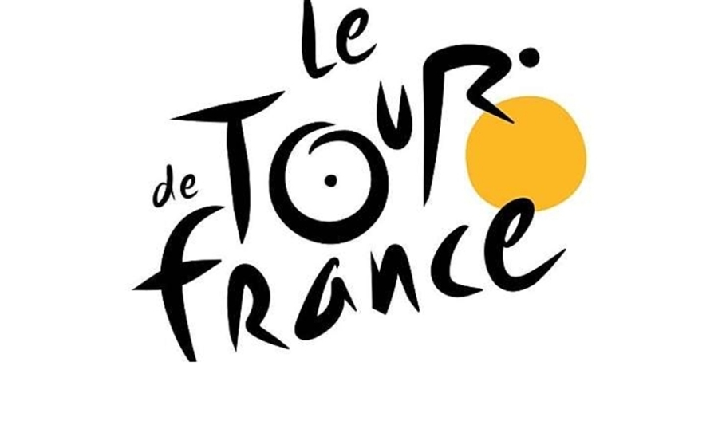

The **Tour de France**, which is the world’s most famous cycle race, was started in 1903. The winning bike rider gets to wear a yellow shirt to show that he is the leader of the race.

**Motto:**

**Liberte, Egalite, Fraternite.**

**(Liberty, Equality, fraternity)**

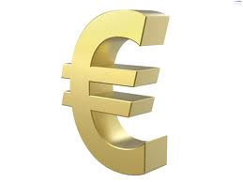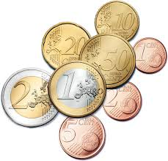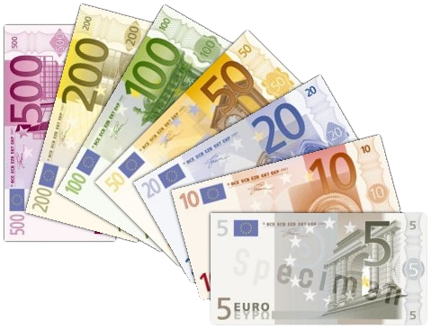

**Currency:**

**Euro**

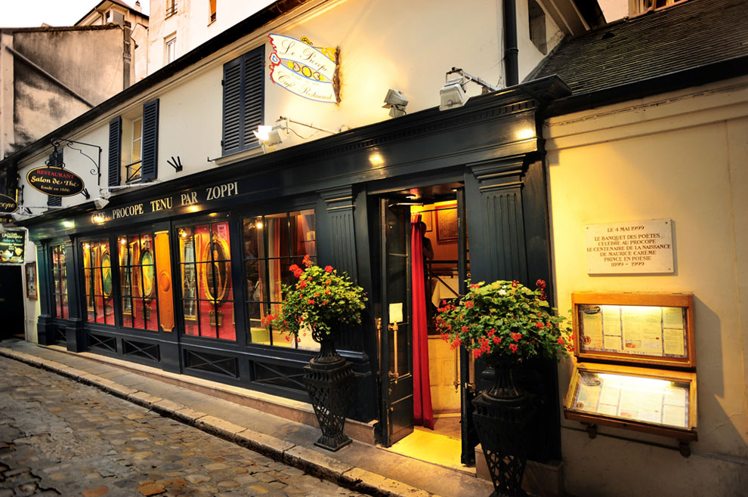

In Paris, you will find the oldest café or coffee shop in the world which was opened in 1694. It is called Le Procope.

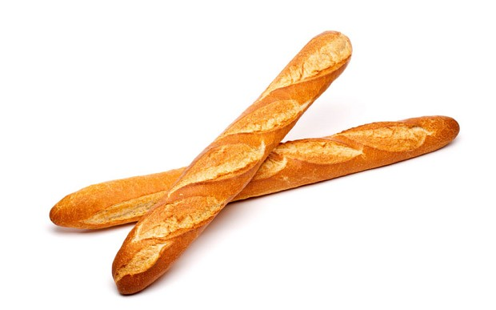

**Baguette**:

long bread stick

**Ratatouille**:

vegetable stew

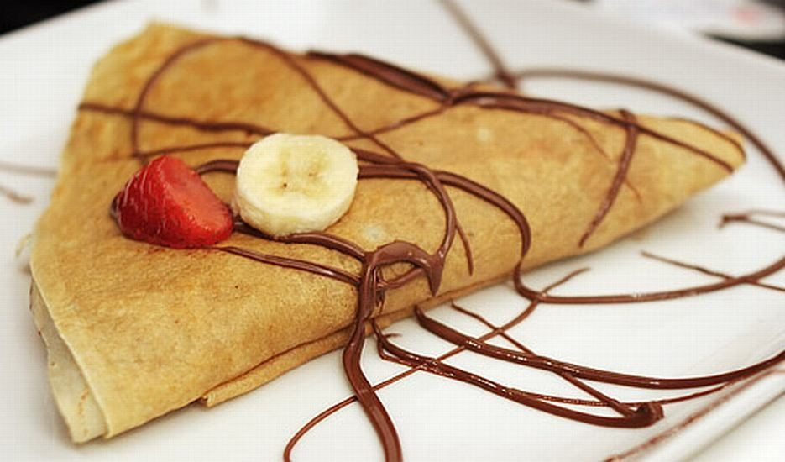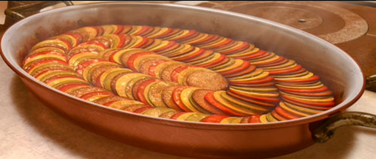

**Crepes**:

Very thin pancakes with filling

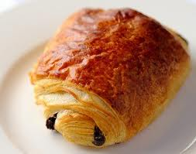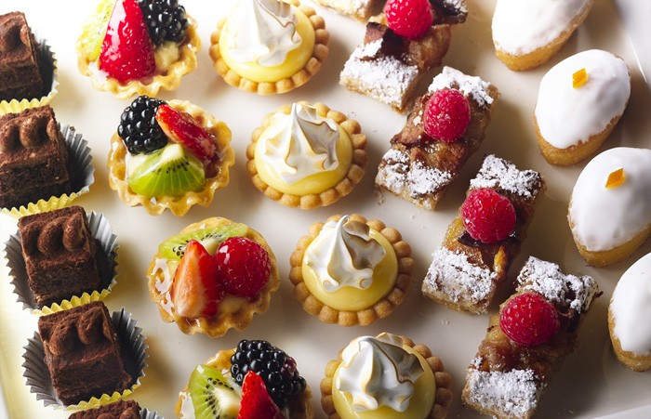

Try to visit also a patisserie for the wonderful sweet like cakes, like the petit fours or pain au chocolat. Don’t forget to eat some pancakes in the many creperies.

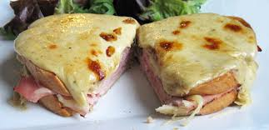

**Croque Monsieur**

Ham and cheese grilled sandwich.

**Croque Madame**

Croque Madame is the more heavy version with ham, cheese and a fried egg on top.

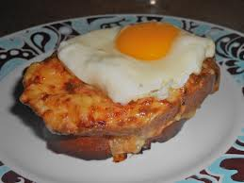

**Capital City:**

**Paris with 2.2 million people living there.**

**Population:**

**More than 65 million people live in France**

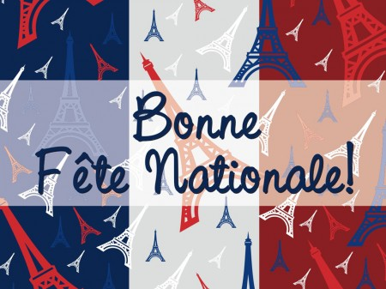

**Comment t’appelles tu?**

**Je m’appelle Luc!**

**Bonjour!**

**Oui, ça va bien merci!**

**Ça va?**