Describe these three different types of house.

|  |  |
| --- | --- |
| http://www.winchestersproperty.com/_images/style/2008.05.17_21-56-19Detached.jpg | Modern House |
| http://www.stedmundsbury.gov.uk/sebc/play/images/AngloSaxonHall200x150.jpg  http://www.museumoflondon.org.uk/NR/rdonlyres/8F4A840E-C565-4586-B200-78889B8190F1/0/403675.jpg | Saxon House |
| http://www.yorkhistoryinpictures.co.uk/Images/tudor_stuart/Houses-M_gate.jpg | Tudor House |

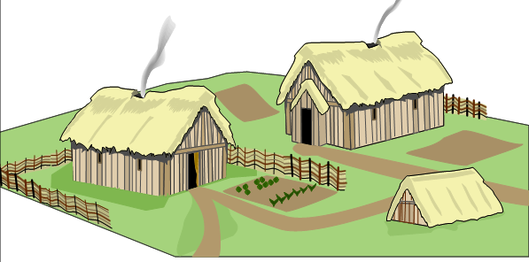

|  |  |  |
| --- | --- | --- |
| Tudor House | Modern House | Igloo |
| Anglo-Saxon Hut | Victorian House | Castle |

