Name _____________________ Date _________________________

Art and Design Rangoli Patterns - Evaluation of my Work
How do I feel about my completed piece of artwork?
_______________________________________________________________________________________________________________________________________________________________________________________________________________________

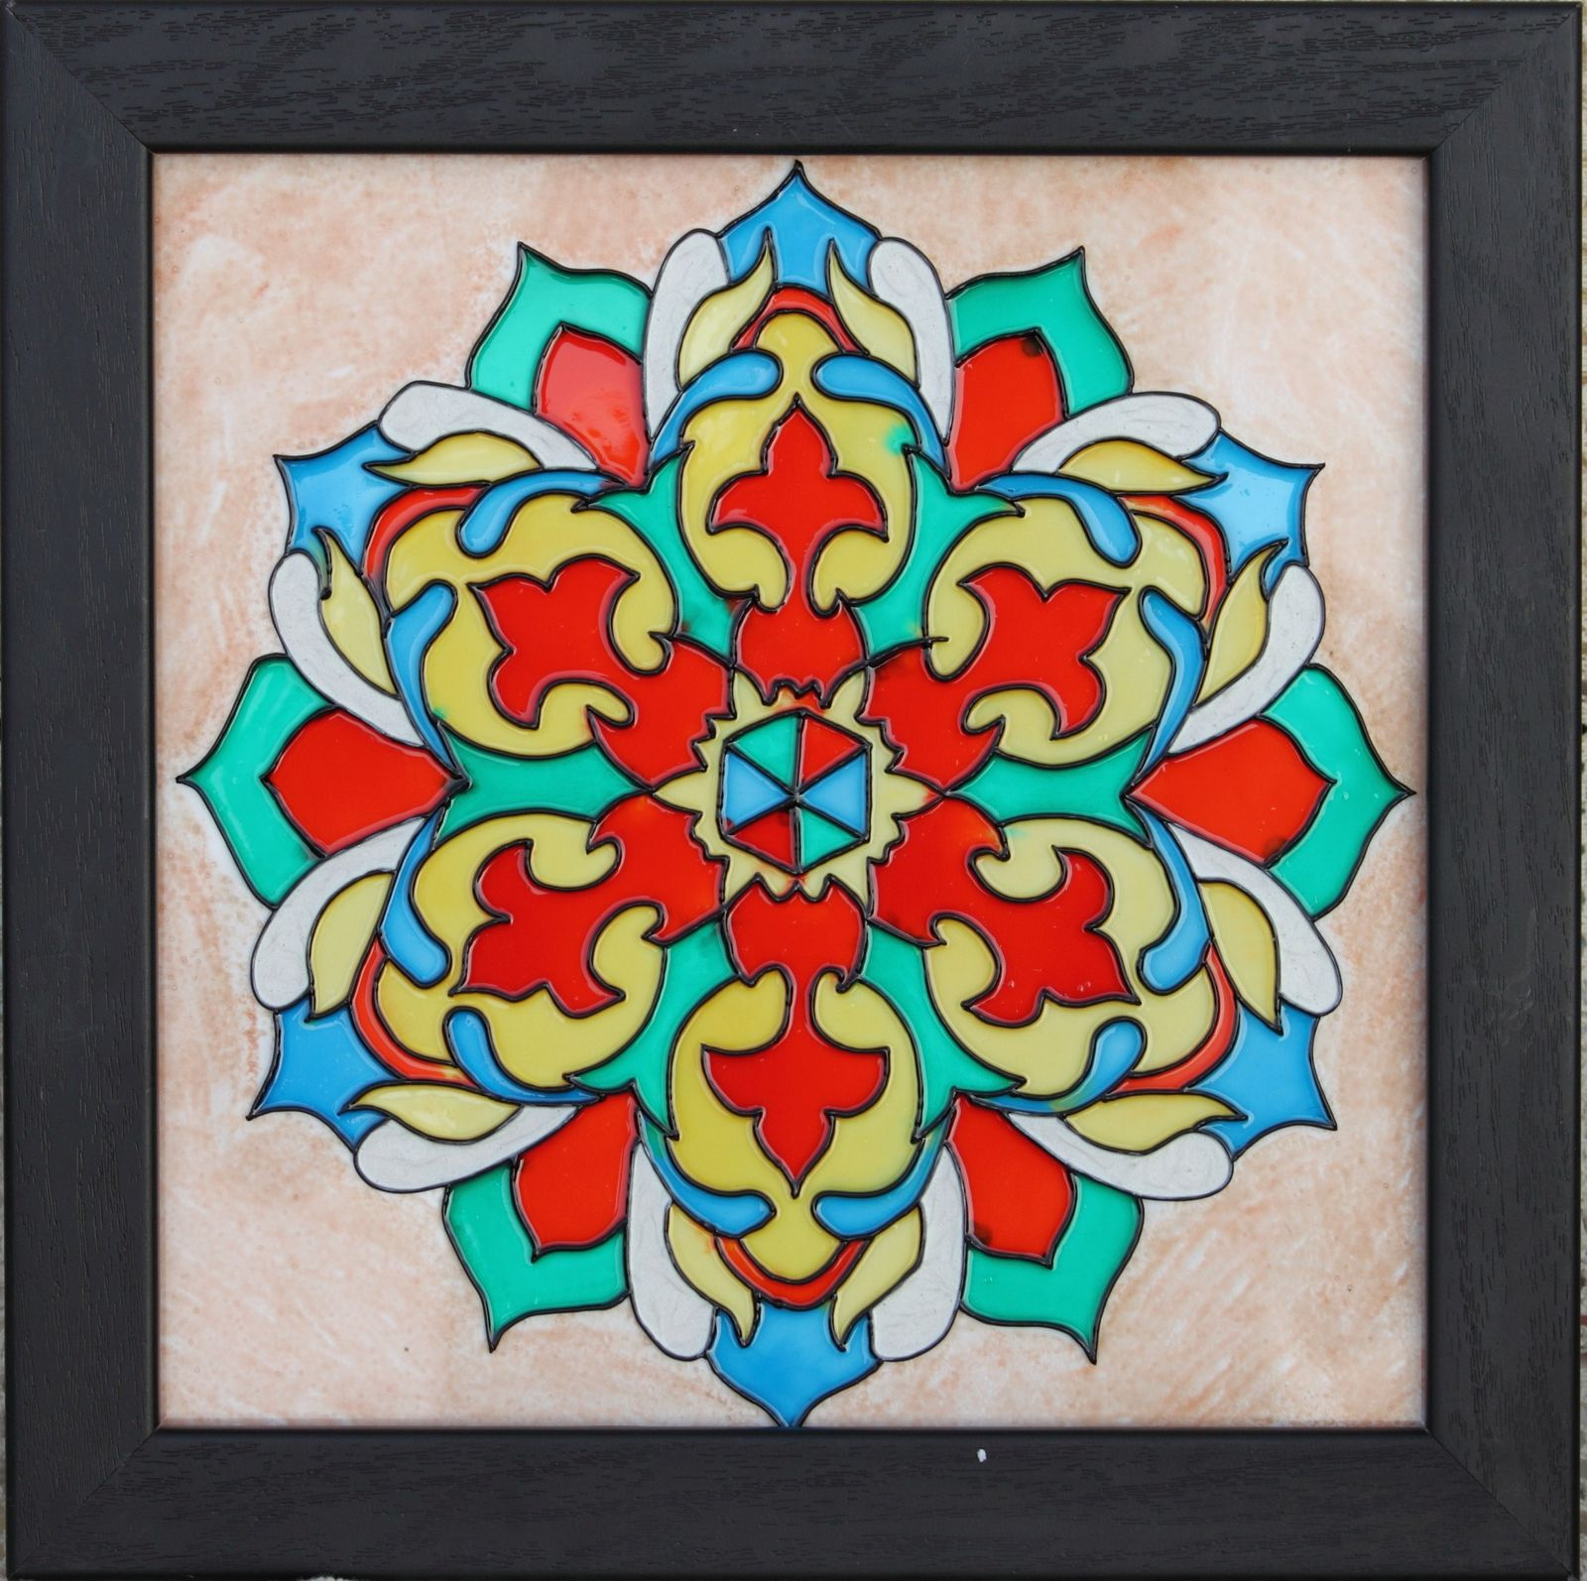
What do I like the most about my artwork? Why?
____________________________________________________________________________________________________________________________________________________________________________________________________________________________________________________________________________________________________________
Is it the same as my original design?
If not how is it different?
_______________________________________________________________________________________________________________________________________________________________________________________________________________________
What did I find the most difficult about my artwork?
____________________________________________________________________________________________________________________________________________________________________________________________________________________________________________________________________________________________________________
What do I like the most about my artwork? Why?
____________________________________________________________________________________________________________________________________________________________________________________________________________________________________________________________________________________________________________

