

Cloakroom Monitor
Library Monitor

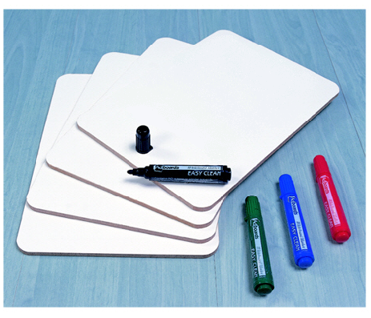

Whiteboard Monitor
Lunch Box Monitor




Monitor
Apron Monitor

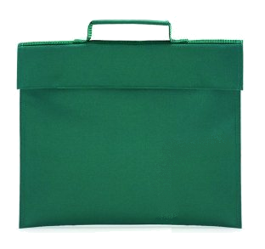

Green Bags Monitor
Line Monitor


בינה אלף Monitor

Cloakroom monitor x 2
Library monitor x 2
Tzedaka monitor x 1
Alef Bina Monitor x 2
Green Bags Monitor x 3
Apron Monitor x 2
Whiteboard Monitor x 2
Line Monitor x 1
Lunchbox Monitor x 2



Dustpan Monitor


Milk Monitor

Classroom
Monitors

