I will use the following equipment: (circle these)

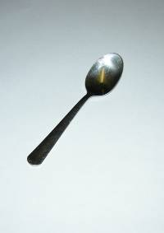 spoon 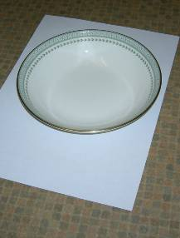 bowl 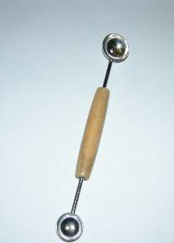 scoop

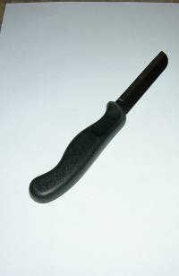 knife 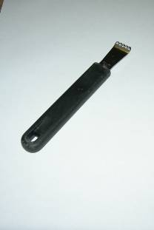 zester 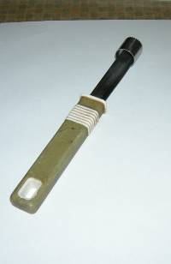 corer

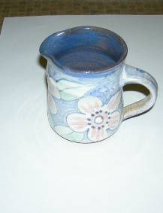 jug 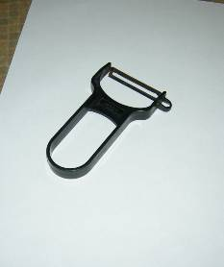 peeler 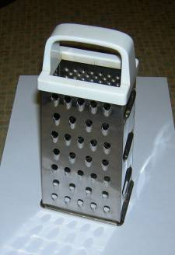 grater

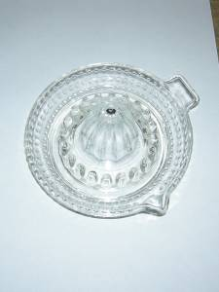 juice extractor 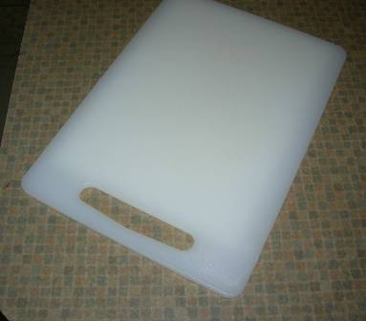 chopping board

I am going to prepare my fruit like this:

(e.g. Kiwi fruit – peel and slice thinly)

My finished fruit salad will look like this:

Here is a photograph of my fruit salad.

Am I pleased with it? __________________ because __________________
_______________________________________________________________
_______________________________________________________________

I could have made it even better by __________________________________
_______________________________________________________________
_______________________________________________________________
_______________________________________________________________

Name:

Who is it for?________________________________________________

I have chosen the following five fruits:

Name of Fruit | Quantity (how much, e.g. ½ apple)

