How to make a torch
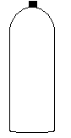
- Get your bottle.

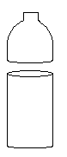
- Cut the top third off and take the cap off.

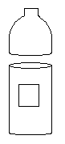
- Cut a square hole out of the side of the bottle.

- Put you circuit and switch in place, so that the switch faces outwards.
- Then line the inside of the bottle top with foil.
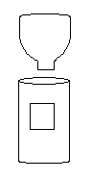
- Place the bulb in the spout of the bottle where it can reflect the light when on.

- Turn the top of the bottle upside down and place in the bottle and secure it.
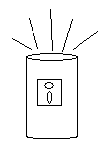

- Try you torch out in the cupboard.

