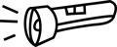 Investigating Torches 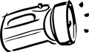

Draw a labelled, coloured diagram of the torch.
Who do you think uses the torch? What do you think it is used for?
What materials is it made from and why do you think they were chosen?
How heavy is it?

Who is the manufacturer? (There might be a name on it.)
What type and how many batteries does it use?
How has it been decorated? Why do you think this decoration was chosen?
Do you like the appearance of it?
How could you improve it? Draw a diagram.
What do other people think of it?
How many marks out of 10 would you give it?

