ANCIENT SANDALS

DESIGN AND TECHNOLOGY
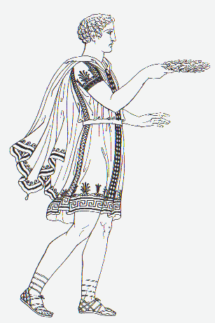
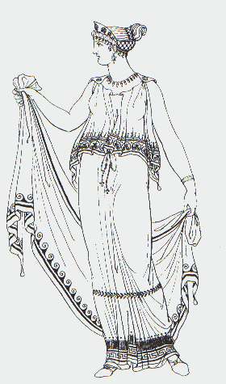

NAME______________________________
CLASS _______________

DESIGN BRIEF
To design and make an ancient sandal for a
Greek man or woman.

Walt:
Date:

Brainstorm below a list of factors an ancient designer would have to consider when designing a sandal:

Designing an Ancient Greek sandal.

WALT :
Date:
1. Materials used:
2. Who is it for? How do you know?

3. What would it be like to wear? Does it look comfortable?

4. Now label each part of the sandal with arrows

Useful words
Upper part
Inner sole
Sole
Straps
Laces
Buckles
Heel
Ancient Sandal

WALT:
Date
1. Draw and label your sandal.
What are the main parts?
Drawing of a Modern Sandal

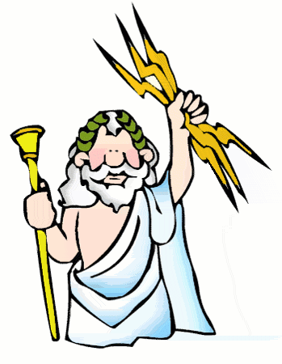

2. What materials have been used? Which parts? (leather, plastic, rubber, buckles, fabric?)

3. What are the different joining techniques? (Glueing? Stitching? Any others?)

4. How comfortable does it look? ________________________________________
Marks out of 10? _________/10

5. Look at the ancient sandal from last week, how is it different from the modern one you have chosen?
New sandal | Ancient sandal
WALT:
Date:

WALT:
Date:

WALT:
Date:
Use this space to sketch a few ideas for your own Ancient Sandal design.
You can also use the back of the paper. Don’t worry about mistakes!

My Chosen Design
From above:

From the side:
Design Criteria

1. I am going to make a sandal for

2. I want my sandal to (list in order of importance):

- _______________________________
- _______________________________
- _______________________________
- _______________________________

Key words you could use:

comfortable soft strong/durable/tough/hard wearing safe colourful attractive/pretty cool
waterproof/non-slip plain looking solid simple

Draw a flow diagram to show the order in which.
Draw a flow diagram to show the order in which you will make your sandal.
7
8
6
5
2
1
3
4
What will you need to make your design?
List it here:
- __________________________
- __________________________
- __________________________
- __________________________
- __________________________
- __________________________
- __________________________
- __________________________
- __________________________
- __________________________

WALT:

You said you wanted your design to do How well does your slipper do each of these things? (mark out of 10 as well)
these things (copy your design criteria here)

Example:
1. To be comfortable It does this fairly well as I have used soft, springy materials. 9/10

1._________________________ _________________________________________________________

2_________________________ _________________________________________________________

3_________________________ _________________________________________________________

4_________________________ _________________________________________________________

What do you think of the sandal overall?
If you were making it again what would you change, and why?

This is a photo of my finished Ancient Sandal.

