Evaluation of Bridges
Name:
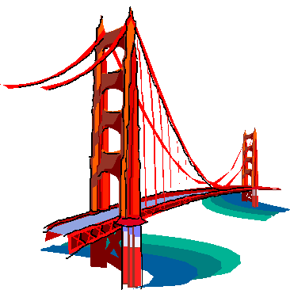
Work with your partner and look closely at the bridge in your picture to answer these questions.
What does it look like?
What do you think it is made from?

Why might these materials have been used?
What different parts are there?
Who would use it?
What kind of bridge is it?
How has it been made strong and stable?
What kind of bridge is it?
Design Project
Name:

You have been asked to design and make a model for a bridge that will allow the people to cross Deep Crevice Valley.

Criteria: Your bridge must…

- _____________________________________________

- _____________________________________________

- _____________________________________________

Other information…

My design ideas!
Name:
Name:
My design!
It will be made from:
The tools I will need are:
I will make it strong by:

I will make it stable by:

