Designing a Fruit Smoothie

Name………………

I will use these ingredients;
Fruit
1.________________________________
2. _______________________________
Base
1.________________________________

I can change it by adding _____________

I will process my ingredients by __________ ____________________________________________________________________

Draw and label a picture of what you are going to use to make your smoothie.

Evaluation.
1st taste
Does your smoothie need changing? ________
How will you change it ? ________________
__________________________________
2nd taste
How does your smoothie taste ? __________ __________________________________
__________________________________

PHOTO of
TASTING SMOOTHIE

Mid
I will use these ingredients;
Fruit
1.________________________________
2. _______________________________
Base
1.________________________________

I can change it by adding _____________

I will process my ingredients by __________ ____________________________________________________________________

Mid
Evaluation.
How does your smoothie taste ? __________ __________________________________
__________________________________
(scribed)

PHOTO of
TASTING SMOOTHIE

WORD BANK
yoghurt | milk | sugar  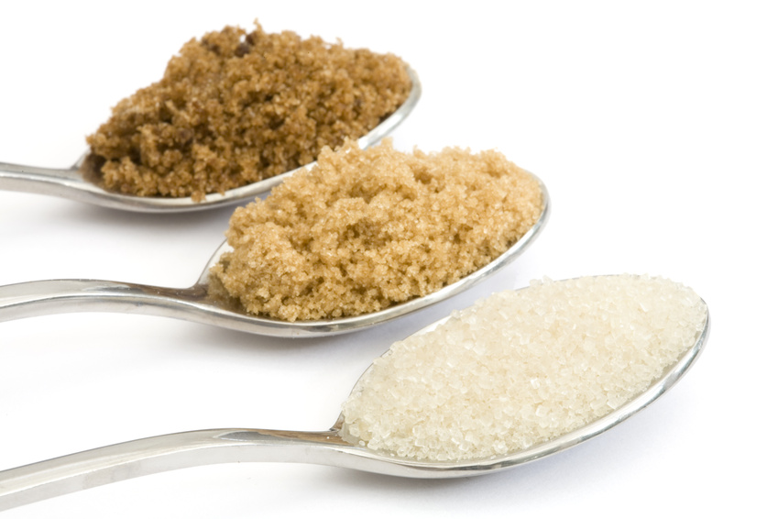 | honey
mango  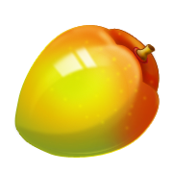 | strawberry | blueberry | raspberry  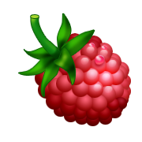
banana | fork | cup

