Torches
Design and Technology

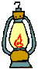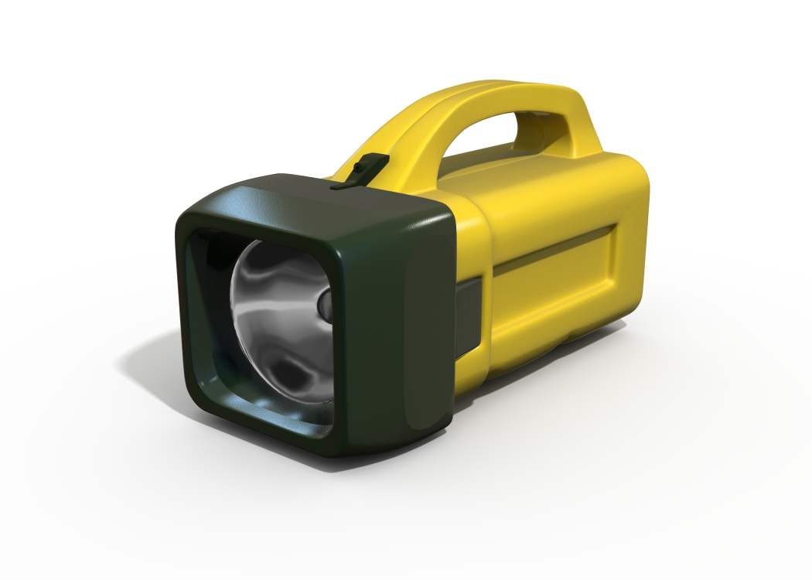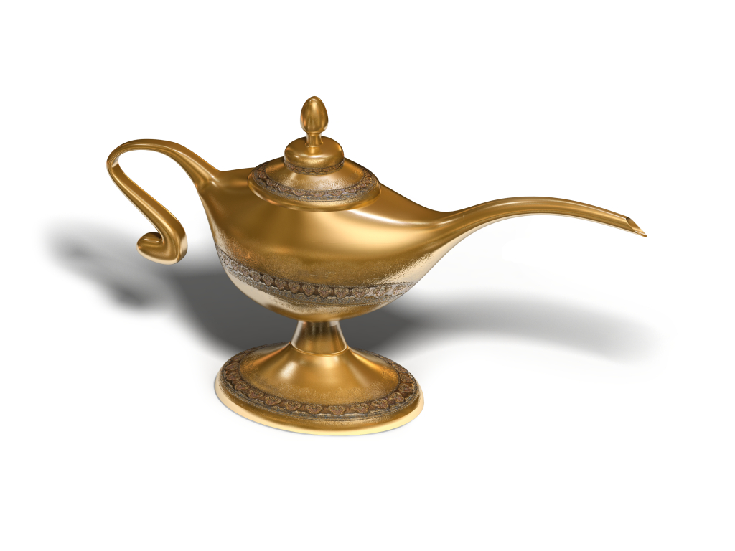

Name _________________
- Investigating Torches.
LI Look at a range of torches and examine them for all their different features. Make a list of the features in the table below.
 | Torch 1 | Torch 2 | Torch 3
What shape is the torch?

Is it heavy or light?

How does the switch work?

How is the light reflected?
How many batteries does it take?
What materials is it made from?
Does it have any special surface textures?
Why do you think it does?

Who do you think this torch was designed for? Why?

- Investigating Switches.
LI Investigate how a switch works and use a variety of materials to make switches.
Draw a simple circuit here including a switch. Label your circuit.

Bulb battery lamp and holder wires switch
List some materials that you could make a switch from:

Why do you think these materials are best for making a switch from?

Plan and design a simple switch here, labeling all the parts and materials :

List the materials you need to make this switch: ______________________
___________________________________________________________
Did it work? ______________ If not why not? ______________________
_____________________________________________________________
Now make a different switch. This time the switch must work in a different way.

List the materials you need to make this switch: ______________________
_____________________________________________________________
Did it work? ______________ If not why not? ______________________
_____________________________________________________________
- Investigating the casing and reflective material.
LI to know that torches are made from a variety of materials that suit the purpose they are to be used for.
Design a reflector for a torch. Draw it, label it and then list the materials you used.

Why did you choose these materials?

Design a reflector for a torch. Draw it, label it and then list the materials you used.

Why did you choose these materials?

4. Plan and make a small light.
LI to plan and make a small light, considering its fit for purpose.
Who will use the light?
What does it need to look like?
What functions does it need to have?
How will you make it safe and reliable?
Design and label your plan

What do you need to make your design?

What steps do you need to follow to make your design?

If you made it again, what would you do differently? _____________________________________________________________________________________________________________________________________________________________________________________________________________________________________________________________________________________________________________ Why? __________________________________________________________________________________________________________________________________________________________________________________________________________________________________________________________________

This is what my new design would look like:

