Adjectives (Size/Colour)+ Sentences.

This is a small, black cat.

_________________________________________.

______________________________________.
____________________________________________

_____________________________________________

_________________________________________

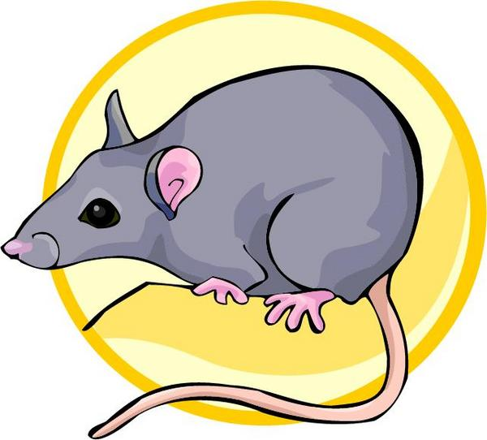 __________________________________________

_____________________________________
FHW 01/06
Unit14 Day2c
big huge fat small little tiny

brown black pink grey blue

