
NOUNS


door
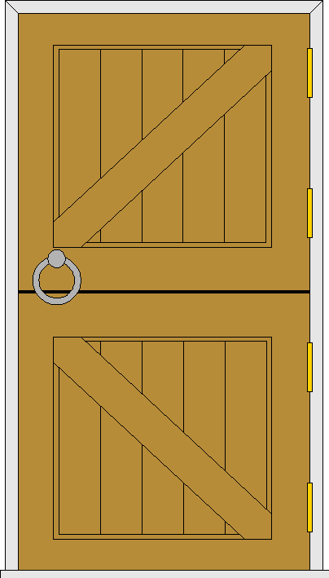

apple
lion
chair
sea

Put the correct NOUN into each sentence:
- The ship sailed on the ____________.
- The man picked the ___________ from the tree.
- The __________ was near the table.
- I opened the __________ and went inside.
- The __________ is the King of the Beasts.

Now, think of your own NOUNS to put into these sentences:
- In English classes, I write with a __________.
- On my way to school, I saw a ____________.
- I will have __________ for lunch today.
- Ruth had to feed her pet __________ before she came to school.
- Alan and Ben played on the __________ in the park.
- My dad has just bought me a ___________.
- I went to the __________ with mum on Saturday.
- My __________ is going on holiday this week.

