Adverbial Clauses
“Here, take it!” cried Jenny, hurling the book at Simon’s feet.
“Here, take it!” cried Jenny, passing the book to Simon.
The words that Jenny says are the same, but adding an adverbial clause changes the meaning of the sentence by telling the reader how she does it.

Change the adverbial clause from below* to change the meaning of the sentence.
- “Let’s get out of here!” yelled Sarah, dragging the dog away from the gateway.
- “You wouldn’t dare come any closer,” cried Bob, throwing his arms across his face.
- “This has been an awful day,” said Jill, her feet squelching in the mud.
- “I’ve finished!” shouted Andrew, putting his book in the tray.

*counting up the points that she had lost.
*throwing his book out of the window.
*staring at the flames.
*picking up the stick.

Choose an adverbial clause from below to add to these sentences.
- “What was the question, Miss?” mumbled Lisa, …
- “We are lost,” groaned John, …
- “And where do you think you are going?” demanded Mum, …
- “I’ve forgotten my ballet kit,” sighed Ellie, …
- “Let me go,” pleaded Tom, …
- “I’ll race you!” laughed Amy, …

…trying to pull free.
…as he peered at the map.
…wishing that she had been listening.
…jumping on her bike.
…rummaging in her PE bag.
…grabbing hold of his arm.
Read this argument between Mark and Amy.
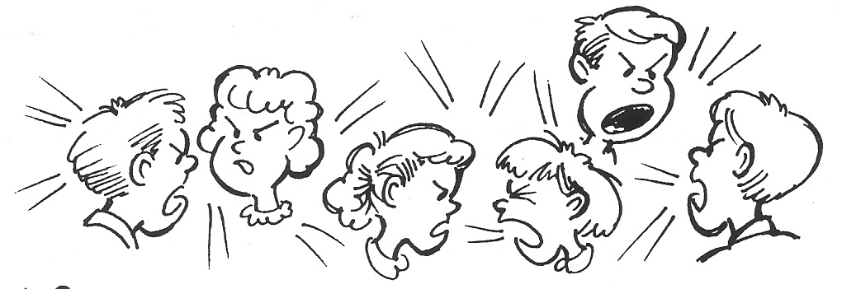
“You did it!”
“I did not!”
“Yes, you did!”
“I did not!”
“I saw you do it!”

Boring, isn’t it?
But if we add a reporting clause and an adverbial clause, it is much more interesting.

“You did it!” Amy said, planting her hands on her hips.
“I did not!” Mark replied, angrily folding his arms.
“Yes, you did!” Amy cried, glaring fiercely at her brother.
“I did not!” Mark yelled, walking away indignantly.
“I saw you do it!” Amy screamed, running after him.

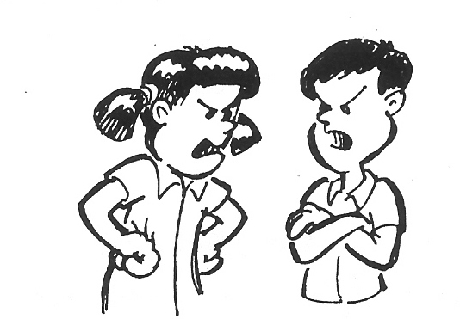
Make this argument more interesting by adding a reporting clause and an adverbial clause to the words they say.

- “Give it to me,” ……..
2. “I don’t want to,” ……..
3. “I said give it to me! Now!” ……..
4. “But I want it!” ……..
5. “Too bad! It’s mine and I want it back,” …..
6. “Take it then, see if I care,” ……..

