Alliteration

Here are some sentences with some words missing.
Fill in the gaps.
There is a list of words in the box to help you.
Choose words that start with the same letter as the sentence.

e.g. Angry Adam ate ants.

- Wobbly Will …………………… wellies.
- Cheeky Charlie …………………… cheese.
- Lovely Laura ………………………… lollipops.
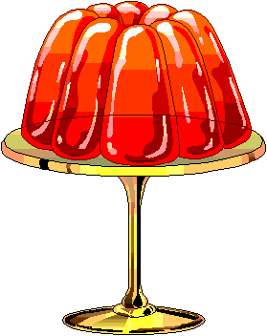
- Jumping Jemima …………………………… jelly.
- Sneaky Sarah ……………………………… sugar.

wears | chews | licks | juggles
likes | wins | chomps | wiggles
spills | shakes | jiggles | loves

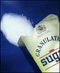
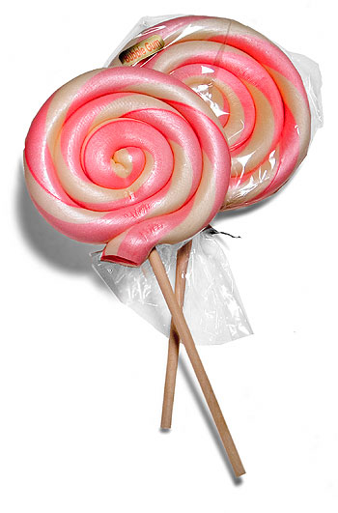
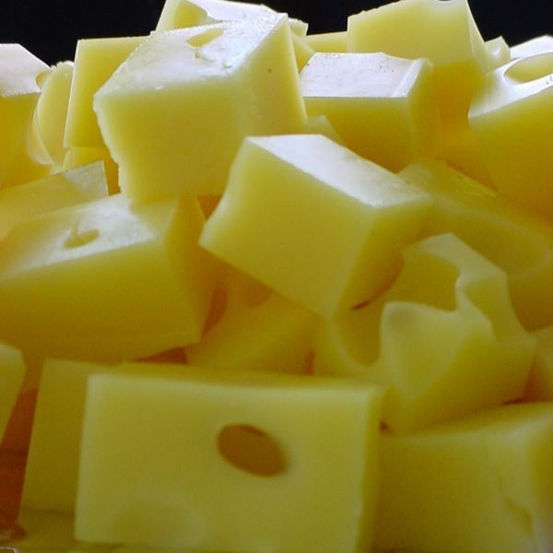

Fill in the missing words. Remember to start the word with the same letter as the sentence starts with.

- One orange ………………………………………………
- Two talking ………………………………………………
- Three terrible …………………………………………
- Four frightening ………………………………………
- Five fun ………………………………………………………
- Six smiley ……………………………………………………
Now you need to think of two words.
- Seven s…………………………………………………………
- Eight e…………………………………………………………
- Nine n……………………………………………………………
- Ten t……………………………………………………………
