Collective Nouns

 | A group of soldiers is called an _____.
 | A large group of people is called a _____.
 | A large group of trees is called a _____.
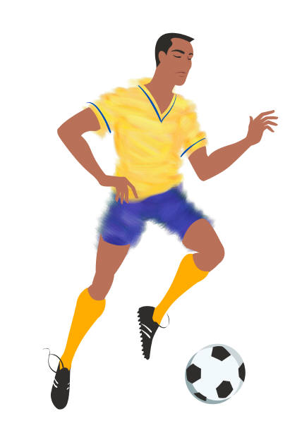 | A group of football players is called a _____.
 | A group of pupils in school is called a ______.
 | A collection of playing cards is called a ________.
 | A group of people who are related is called a ________.

team | pack | forest | family | army
 | crowd |  | class
Collective Nouns (2)

A ________  of geese. | A ________  of wolves. | A ______  of bees.
A _______  of elephants | A ________  of lions. | A ______  of sheep.
A _______  of hedgehogs | A ________  of whales. | A ________  of rabbits.

pack | flock | herd | pride
prickle | gaggle | swarm | school
 | colony

