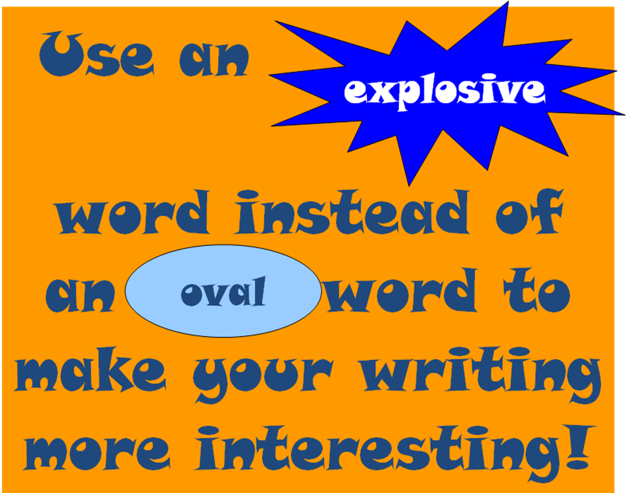
Good

Excellent

Superb

Splendid

Exceptional

Wonderful

Nice

Pleasant

Charming

Fascinating

Delightful

Pleasurable

Then

Later
Second
Third
Next
Afterwards
Meanwhile
Soon
Truly
Shockingly
Horribly
Fully
Badly
Surely
Powerfully
Very

Especially
Bitterly
Extremely
Unusually
Incredibly
Lots

Many

Numerous

Hundreds

Dozens

Innumerable

Cool

Awesome

Brilliant

Marvellous

Fantastic

Great

These words are great if you cut them out (or get the pupils to) and laminate them. I have mine all around the English display board, effective and useful for expanding vocab. The words are colour coordinated with the boring word in pastels and the exciting alternatives in bright versions of the pastel!

