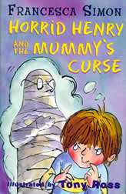
Horrid Henry and the Mummy’s Curse
By

Francesca Simon

Week 1 Page 9-23
- Who is the illustrator?
- What is the name of Horrid Henry’s younger brother?
- What did they both collect?
- What was Henry’s brilliant, spectacular idea?

Week 2 Page 24-41
- What did Henry do in the Happy Shopper that resulted in a life time ban?
- What homework did he have to do?
- How many times had Henry got ZERO in his spelling test?
- What was Miss Battle-Axe going to give everyone who got their words correct?

Week 3 Page 42-59
- What was Henry doing when he was sitting next to Clever Clare?
- What did cheating get Henry?
- What was the worst day of the week and why?
- What trunks did Henry eventually wear?

Week 4 page 60-73
- What trick did Henry play on Aerobic Al?
- Where was the brand=new ‘Curse of the Mummy’ kit?
- What did Henry do with the loo roll?
- What happened to Henry in the end?

Week 5 and Week 6
Draw a picture from the book and start a book review.

