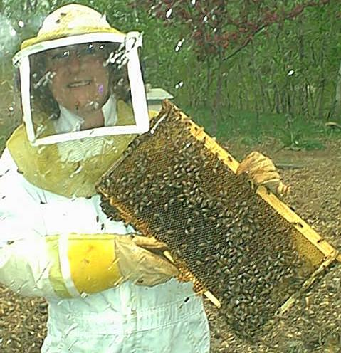
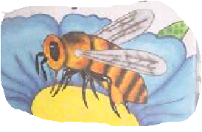
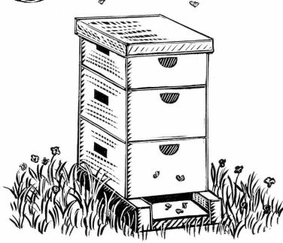
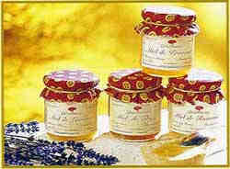
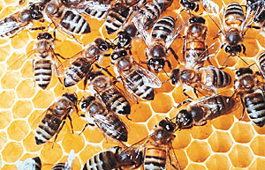
How Honey Is Made
The bee sucks nectar with its mouth, which is shaped like a tube.
Bees fly hundreds of times between flowers and their honeycombs.
In the country, some bees make their nests in places like the trunk of a tree.
Bees make honeycombs with wax from their own bodies. The gaps in the honeycomb are where the honey is stored.
In gardens or farms, beekeepers keep bees in beehives like this one so they can collect honey. About fifty thousand bees live in one beehive.
The beekeeper collects the honey from the beehive. He takes out the honeycomb which is full of honey.
He is dressed in special clothes so that he doesn’t get stung.
Honey is used in lots of different recipes. It is delicious when it is spread onto bread.
Getting Nectar
Making Honey
Beehives
The Beekeeper
Ready to Eat!

