Honey Stomach
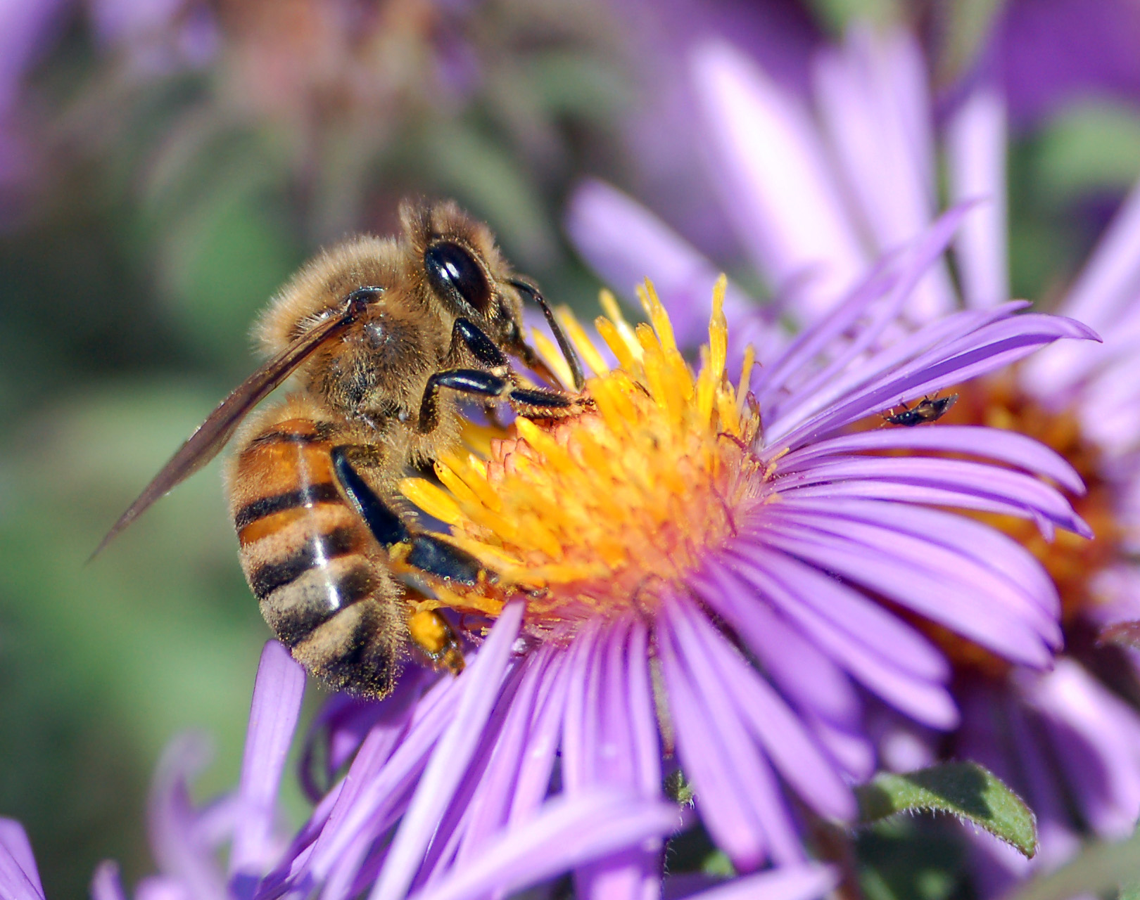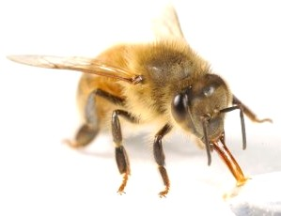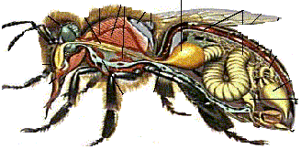
Bee’s Tongue

Bees drink nectar from flowers using their long tongue. Their tongue is nearly twice as long as their body. This helps them reach the nectar inside the flower.
Bees store the nectar in a special sac called a Honey Stomach. Inside the stomach the nectar is broken down into two sugars.

Inside the Honey Stomach special enzymes help change the nectar into two sugars called FRUCTOSE and GLUCOSE.
Inside the Honey Stomach
Nectar
Enzymes
Fructose
Glucose
Water
Wax Cap

Nectar in cell

The heat in the hive helps water evaporate from the nectar and it turns into honey. The bees then cover the cell with a wax cap.

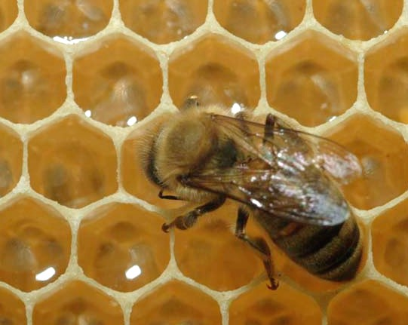
The bee returns to the hive where it spits the nectar from its Honey Stomach into one of the cells.

