


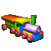
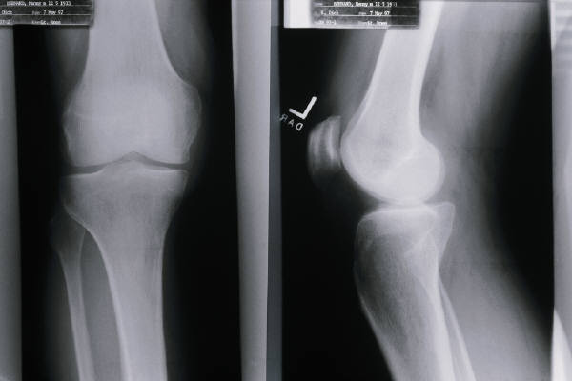
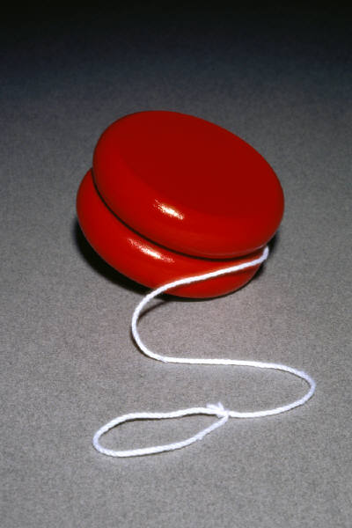
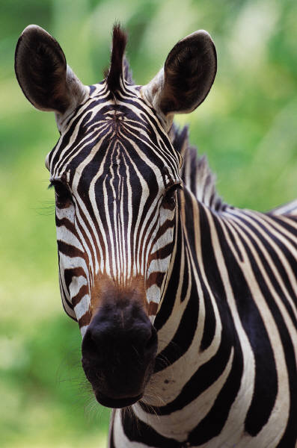
z
t
x
w
p
r
q
v
n
m
l
g
h
j
k
d
b
y
c
f
s
u
o
i
e
a

Suggestions for use after laminating

- roll die across board and name letter sound or initial picture sound landed on
- ask child to name initial picture sound or letter sound at random
- use dry wipe pen to connect letters to match initial sound of pictures
- point to letter sound, ask child to name things beginning with the sound in addition to the one on the mat

