Name: _____________________ Date: ______________

The Long E sound

Decide which sound these words use: ee or ea

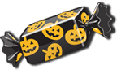

Name: _____________________ Date: ______________
The Long E Sound
Decide which sound these words use: ee or ea
bea, bee | feet, feat | tree, trea | pees, peas
queen, quean | leef, leaf | flee, flea | seeds, seads
sweet, sweat | beech, beach | teeth, teath | sneeze, sneaze
sheep, sheap | teecher, teacher | three, threa | peech, peach
street, streat | seel, seal | wheel, wheal | beens, beans

