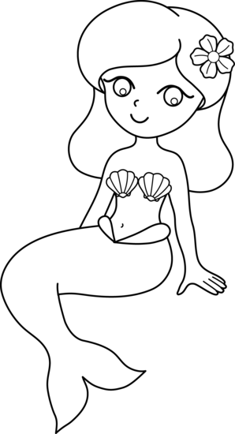
Fantasy World Stage 6

Flora to the rescue

- Answer the questions by ticking the answers.

What was under the sea?

a magic carpet a magic kingdom a car

Where did Marven hide?

a tent a dive a cave

What was Marvin stuck in?

a cave a whale a kingdom

Why was Big Mouth cross?

He could not find them. He was hungry.

- Number these sentences in the correct order. You may want to write down what page each sentence is on to help you.

Page |  | Order
 | Big mouth opened his mouth.
 | Marvin swam off to hide.
 | Flora and Marvin swam under a rock.
 | Big Mouth tried to catch them.
 | Flora could see some fish.
 | Big Mouth swam off looking very cross.

Read and draw. Big Mouth swam into a cave. He tried to catch Marvin and Flora who swam under a rock.



What are the characters saying?

