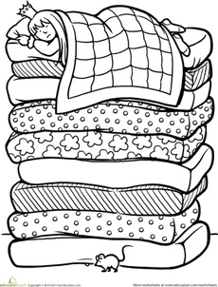
Once Upon a Time World Stage 6

The Princess and the Pea

- Answer the questions by ticking the answers.

What was the weather like?

rain thunder sunshine lightning

Who was the girl at the door?

a prince a queen a princess a king

What did the queen out in the bed?

a mattress a quilt a pea a quilt

What did the king do before going to bed?

blow out candles climb into bed eat supper

- Number these sentences in the correct order. You may want to write down what page each sentence is on to help you.

Page |  | Order
 | There was a big storm and a girl came to the door.
 | The princess could not sleep.
 | A prince wanted to find a princess.
 | The king blew out the candles.
 | The queen went to make a bed for the princess.
 | The pea was put in a glass for all to see.

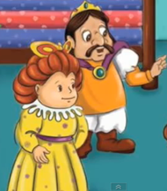

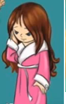

What are the characters saying?

