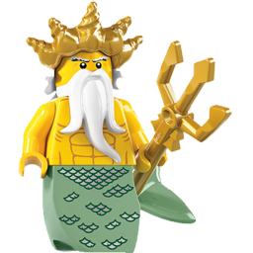
Fantasy World Stage 6

Slug the Sea Monster

Read each sentence and tick if the sentence is true
or false.

 | True | False
A sea monster called Slab lived in a magic kingdom.
Flora gave Slug a jellyfish.
Flora swam fast so Slug could not catch her.
The king had a magic tide.
The king made Slug into a little slug.
Slug was happy when he was big again.

Fill in the missing words.
some was the but
to want on said

Under the sea ________ a magic kingdom. Slug wanted something _______ eat. Nipper gave Slug _________ seaweed but he didn’t __________ to eat it. Slug tried to catch Flora ___________ swam off fast. She went to find ________ King of the sea. ‘Stop that now,’ __________ the king of the sea. As Slug opened his mouth the king blew _______ his magic trident.

