The Highwayman 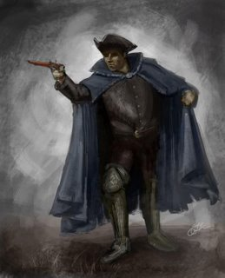

The Highwayman by Alfred Noyes is written in true ballad form and is full of action, drama and passion.

Ballads have their roots from storytelling around a fire (believe it or not people haven’t always had televisions!) and that many of the early ballads were never written down. Audiences included all members of the family and local community, so ballads were made simple. By being simple they were easy to understand and therefore easy to remember. These ballads could then be told over and over again.

Read through the poem and then answer the questions below; these will help you to understand the poem.

- What does the Highwayman look like?
- Why has the Highwayman rode to the inn?
- What does Bess the landlord’s daughter feel about him?
- What does Tim feel about the Highwayman? ( what information in the poem tells you this?)
- “Yet if they press me sharply, and harry me through the day, then look for me by moonlight……” What do you think this line means? (verse 5)
- Verse 7 describes the arrival of King George’s soldiers, how do you think they know the Highwayman was coming?
- The soldiers tied Bess to the bed by the window why?
- What does Bess do to stop the Highwayman from coming to the inn?
- How does the Highwayman respond to the news about Bess?
10. Does the poem have a happy or sad ending? Explain in your own words.

EXTENSION

What language in the poem indicates that the story is from a long time ago?

