The Highwayman 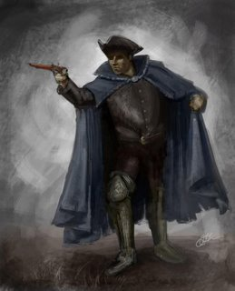

The Highwayman by Alfred Noyes is written in true ballad form and is full of action, drama and passion.

Ballads have their roots from storytelling around a fire (believe it or not people haven’t always had televisions!!) and that many of the early ballads were never written down. Audiences included all members of the family and local community, so ballads were made simple. By being simple they were easy to understand and therefore easy to remember. These ballads could then be told over and over again.

Read through the poem and carefully explore each of the verses can you identify what the structure is?

The wind was a torrent of darkness among the gusty trees,
The moon was a ghostly galleon tossed upon cloudy seas,
The road was a ribbon of moonlight over the purple moor,
And the Highwayman came riding –
Riding – riding-
The Highwayman came riding, up to the old inn door.

If we look carefully at verse one you can see that the poet has used rhyming couplets so that lines 1 and 2 and 3 and 4 rhyme.

Metaphors have been used to express detailed descriptions and create clear visual images in lines 1, 2 and 3.

He has used alliteration in line 3.

Repetition has been used in a clever way in lines 3 and 4. Each time there is a slight difference. This difference adds more details and creates a kind of 2 line chorus or a catchy hook line.

To create and sustain the rhythm each line is about the same length. This means that each line has roughly the same number of syllables and thereby helps to control the speed and rhythm of each line.

TASK

With a partner explore verse 2 below; does the verse follow the structure? Can you identify the alliteration that has been used? Does it add a little detail each time? What rhyming couplets have been used? What has been described? Have metaphors been used? Is there a 2 line chorus/hook line?

He’d a French cocked-hat on his forehead, a bunch of lace at his chin,

A coat of the claret velvet, and breeches of brown doe-skin;

They fitted with never a wrinkle: his boots were up to the thigh.

And he rode with a jewelled twinkle,

His pistol butts a-twinkle,

His rapier hilt a-twinkle, under the jewelled sky.

Used coloured pencils to highlight the structure elements i.e. alliteration green, metaphors blue, rhyming couplets yellow

Extension

Read through the rest of the poem with a partner and check that each of the verses follows this structure.

