The Highwayman 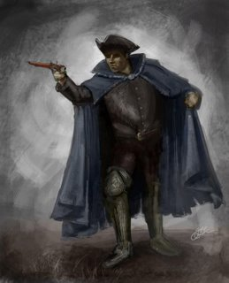

The Highwayman by Alfred Noyes is written in true ballad form and is full of action, drama and passion.

Ballads have their roots from storytelling around a fire (believe it or not people haven’t always had televisions!!) and that many of the early ballads were never written down. Audiences included all members of the family and local community, so ballads were made simple. By being simple they were easy to understand and therefore easy to remember. These ballads could then be told over and over again.

Read the verse. What is the poem structure?
The wind was a torrent of darkness among the gusty trees,
The moon was a ghostly galleon tossed upon cloudy seas,
The road was a ribbon of moonlight over the purple moor,
And the Highwayman came riding –
Riding – riding-
The Highwayman came riding, up to the old inn door.

Poem structure

If we look carefully at verse one you can see that the poet has used rhyming couplets so that lines 1 and 2 and 3 and 4 rhyme.

Metaphors have been used to express detailed descriptions and create clear visual images in lines 1, 2 and 3.

He has used alliteration in line 3.

Repetition has been used in a clever way in lines 3 and 4. Each time there is a slight difference. This difference adds more details and creates a kind of 2 line chorus or a catchy hook line.

Task

Using the poem structure can you write an alternative ending to the poem, where poor Bess doesn’t die!

For example:

Clip-Clop the hooves did echo in the frosty night.

The Highwayman came riding, brave and full of fight.

He rose up from his stirrups and cut her ropes in a single stroke.

The Highwayman claimed his loved one, his beautiful faithful loved one,

His faithful loved one who waited with a red love knot in her hair.

