The Owl Tree – Chapter One

1. A. What season does this story begin in? ____________

B. Write the words from the chapter which prove this
fact. ____________________________________

2. Why had the children come to stay at Granny Diamond’s
House? _____________________________________
___________________________________________

3. Where was the children’s own home? _______________
___________________________________________

4. Why was the tree so special to Granny Diamond?
___________________________________________
___________________________________________

- Granny Diamond was not very pleased when Joe said the Owl Tree was not hers. What words from the story tell us this? __________________________________________
__________________________________________

6. The tree was losing its leaves. Trees which lose their
Leaves are called ______________trees.

- Make a list of trees of this type. Use the library and/or
the internet to help you.
________________________________________________
________________________________________________
________________________________________________
________________________________________________

The Owl Tree – Chapter Two Patchwork Thinking

Find links between the joined sections in the patchwork quilt.
Write your ideas in the boxes between the sections.

ghosts

neighbours

monster

lights

Hallowe’en

Mr. Rock

friends

Joe

falling

food

wall

tree
The Owl Tree – Chapter Three Decision Making

If you owned the tree, would you cut it down?

Cons:
Pros:

Have you changed your mind?
Why?

The Owl Tree – Chapter Five

Here are the answers to some questions. Write a question about the chapter to match each answer.

- A. Joe pretended he didn’t exist so that he wouldn’t get hurt.
Q. ______________________________________________

- A. The breath of warm air came from a dog.
Q. ______________________________________________

- A. His pet name for Minna was Tomboy?
Q. ______________________________________________

4. A. The best place to see it was in the lane.
Q ______________________________________________

5. A. Minna wasn’t interested in the tree.
Q. _____________________________________________

6. A. Joe was to choose a name for the baby.
Q. _____________________________________________

- A. He was ashamed because he wasn’t brave enough to help
Granny Diamond.
- _____________________________________________

- A. They had four days left.
- _____________________________________________
On the other side of the page, write four open-ended questions about this chapter.

The Owl Tree – Chapter Six

1. Find the words below

I R H T I L W D T D F D
V N D E K M H P E R L A
S C Q K A X L S O D I D
H U P U D V P K E B C E
R T D X I E E H L Y K S
I K O E R S S D A U E O
E K F A L I I I I Q R L
K D T C N B P T E S I C
S E W A C F M J I B N N
E W V N L H U U H V G E
S N I G G E R W T H E A
D E L P M U R C W S O K

CRUMPLED
DESPERATE
ENCLOSED
FLICKERING
HEAVED
INQUISITIVE
SHRIEK
SNIGGER
STUMBLED
VANISHED

2. Now use each word in a sentence of your own.
_________________________________________________________________________________________________________________________________________________________________________________________________________________________________________________________________________________________________________________________________________
The Owl Tree – Chapter Seven

Joe saw a barn owl in the tree.
Use the internet and the library to find facts about the barn owl

Food
Habitat

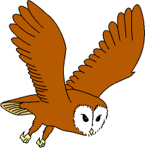
Other interesting facts
Sound
Behaviour

Appearance
Colour of back and wings:

Colour of underside:

Shape of face:

Size
Length of body:

Wingspan:

The Owl Tree, Chapter Eight - Fact or Opinion ?

  - Tick the correct box for each one:
  - Add two more facts and two opinions from the book to
the table
statement | fact | opinion
Minna spent a lot of time with the Ludds

Joe was a great climber

Alex and his dog came to see Joe

Hunting mice and voles to eat is disgusting

Putting a ring on birds is cruel

Putting rings on birds helps people to know more about them
Mr Rock is very ugly

Joe only had two days left to save the tree

Playing with leaves is good fun

Owls are beautiful

The Owl Tree – Chapter Nine
Complete the table with your own meaning of the word. Then choose he correct meaning from your dictio
word | my meaning | dictionary meaning
intensified

agitated

emerged

hollow

troubled

beam

hauled

roosted

Use each word in a sentence of your own.

Dictionary.
The Owl Tree – Chapters One to Ten

Retell the whole story in ten sentences:

The Owl Tree - Chapter Four

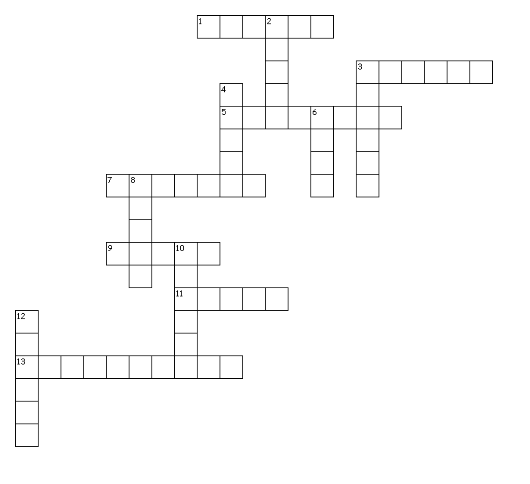
Across
1. Worn by a pilot
3. Metal for a photograph frame
5. Granny Diamond behaved in this way
7. Imaginary creatures
9. A type of tree
11. Fabric for making jackets
13. Featured in every picture
Down
2. Entertainment for Minna
3. Cast by the monster
4. Dropped on the floor
6. Fuel for the monster's fire
8. A vegetable that makes you cry
10. The season in which the story is set
12. Rattled by Minna in the kitchen

