The Tree House – Chapter One

1. Which brother is the oldest?
_____________________________________________________________

2. Where was the Chestnut tree?
____________________________________________________________________________________________________________________________

3. What two things did Dadda have to do before he could start to build
tree house? ____________________________________________________________________________________________________________________________

4. When did they plan the tree house? ______________________________________________________________
______________________________________________________________

5. In what month did Dadda start to build the tree house?
____________________________________________________________________________________________________________________________

6. Who was the ferocious monster?
______________________________________________________________

7. What country is Dadda going to work in?
______________________________________________________________

8. How do you think William felt about his dad going away?
____________________________________________________________________________________________________________________________

9. How do you know William felt this way?

The Tree House – Chapter Two

1. Correct the spellings of these words from chapter two.
parsel -------------------- climing ------------------

lader ---------------------- cassel ------------------ 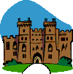

cuboard ---------------------- rassberries --------------------

2. Change the bold verb to another one in each of these sentences

Sprog picked up the string and wound it neatly round his finger.
______________________________________________________________

William’s eyes gleamed.
______________________________________________________________

He seized one bowl and ran down the garden.
______________________________________________________________

William began to climb down again, very cautiously.

The Tree House – Chapter Three

William used his imagination to see lots of exciting things through the
binoculars. Use your imagination to think of six exciting things you
would see from the tree house.

The Tree House – Chapter Four

William and Sprog made a cord telephone from the
toffee tins. Write a set of instructions for making a cord telephone like theirs.

How to ___________________________________________

You will need:

1. _________________________________________________
____________________________________________________

2. __________________________________________________
____________________________________________________

_____________________________________________________

The Tree House – Chapter Six

1. William and sprog used their torches to make up secret codes.
Colour the lights and write what the secret code words are:

white red yellow green red, then green
___________ ________ _________ __________ ____________
___________ _______ _________ __________ ____________

2. Use this code to write a secret message

______________________________

______________________________

_____________________________

_____________________________

3. Sprog shone ‘red, then green’ out the window to William. What was the good thing Sprog wanted William to come in for?
____________________________________________________

4. Why do you think the boys wrote ‘red, then green’ on their letter?
_____________________________________________________
_____________________________________________________
The Tree House – Chapter Seven

1.Design a tree house. Draw a picture of it and label it in the box below.

2. Who would you like to have with you in the tree house?
__________________________________________________________________________________________________________

3. Write about what you would do in a tree house like this.
______________________________________________________________________________________________________________________________________________________________________________________________________________________________________________________________________________________________________________________________

The Tree House - Chapter Five
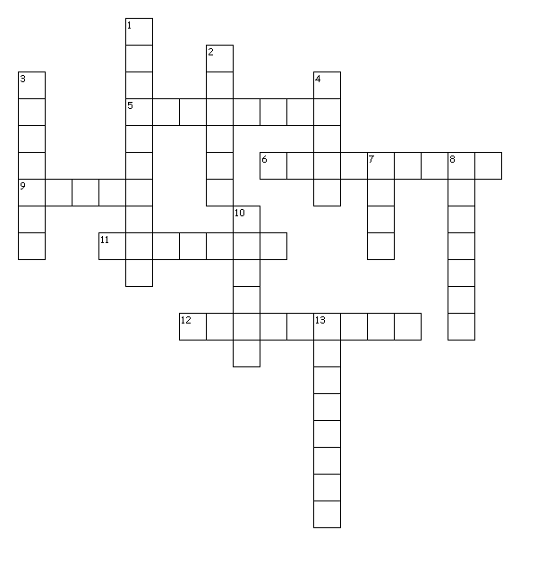Across
5. Wiliam thought this was useless.
6. Dad drew these on the letter.
9. Sprog made this out of the umbrella.
11. There were two of these left.
12. These had fallen from the tree.
Down

1. This is thrown at enemies.
2. Sprog tied this to the umbrella.
3. They wear armour.
4. There was a secret hole behind this.
7. William slammed this.
8. Chestnut cases are like this.
10. The boys sent one to Dad every month.
13. The month the parcel arrived.

