Jump like jolly jumping beans
Wiggle like a wiggly worm
Slither like a slippery snake
Flap like a flying flamingo
Crawl like a creepy crawly caterpillar
Run round like a racing rabbit
Tiptoe like a tiny turtle
Dance like a dog with a drum
Hop like a happy hippopotamus
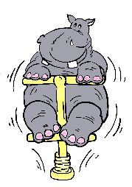
Spin like a super spinning top

Skip like a silly seal

