LO to identify the main features and places of interest on a map of Struay
Name ............................................................................................................ Date .......................................
The island of Struay
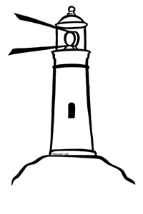
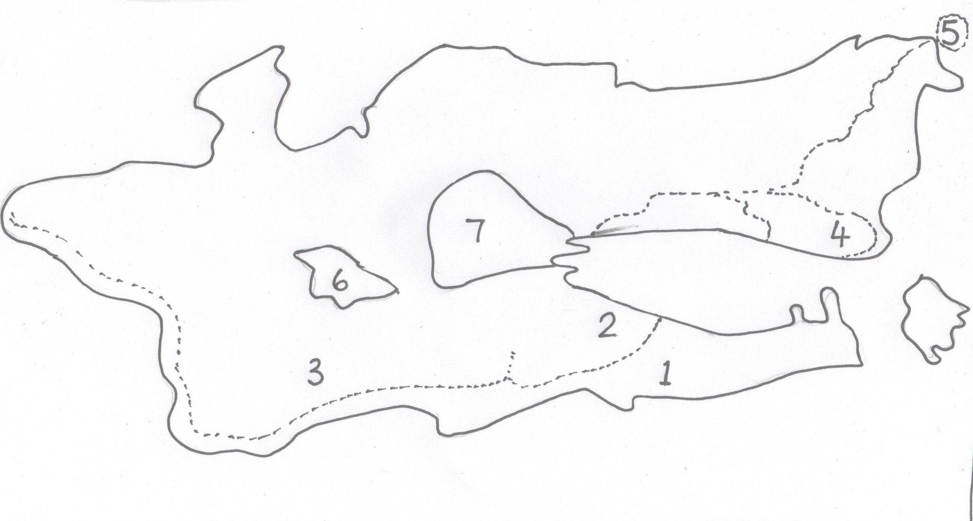
Word bank

Bonny Loch 
School 
Castle 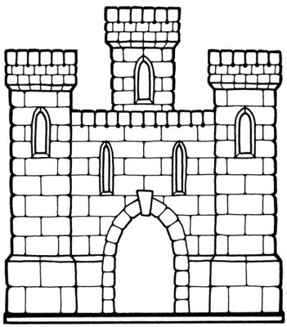
Shop and post office 
Grannie Island’s house 
Blue eye lighthouse

Forest 

Colour the sea blue. Identify and write the places that are numbered in the key. Draw the features on the map

Key
1 | 5
2 | 6
3 | 7
4

Extension activity.
Find out where these features are and draw them on your map

Boorachy bog 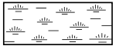

Redburn bridge 

Kiloran bay 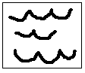

New pier 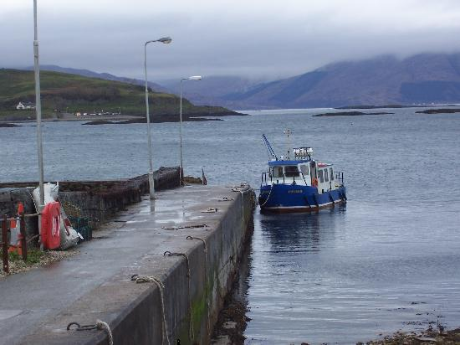

Write directions for Katie Morag to walk from Grannie Island’s house to her home at the Post Office. Explain which direction she needs to take and name some of the landmarks she will pass.
north

west
east

south

........................................................................................................................................................................................................................................................................................................................................................................................................................................

