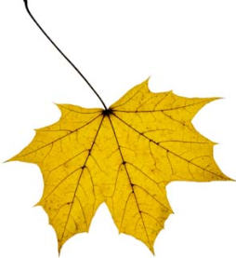
I Love Autumn!

Choose a leaf to write about. It could even be your own one!
Draw a picture of your leaf and what it is doing!

What colour is your leaf? ________________________________.

What shape is your leaf? _________________________________.

What is your leaf doing? __________________________________.

Where is your leaf? _______________________________________.

Now write four lines about your leaf.

________________________________________________

________________________________________________

________________________________________________

________________________________________________

I Love Autumn!

Choose a leaf to write about. It could even be your own one!
Draw a picture of your leaf and what it is doing!

What colour is your leaf? ________________________________.

Yellow Red Green Orange

What shape is your leaf? _________________________________.

Spikey Round Wavy

What is your leaf doing? __________________________________.

Falling Dancing Flying Floating

Where is your leaf? _______________________________________.

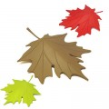
On the ground On a rainbow Under your feet On your head

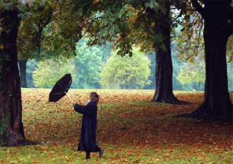
I Love Autumn!

You are going write about AUTUMN WEATHER!
Draw a picture of your autumn weather and what you are doing!

What is your weather like?

__________ __________ ___________ ____________

Write some weather adjectives.

____________ ____________ _______________

_____________ ____________ _______________

What are you doing in the weather?

I am splashing in the puddles.

_______________________________________________________

_______________________________________________________

_______________________________________________________

Now write your Autumn Weather poem!





