AW
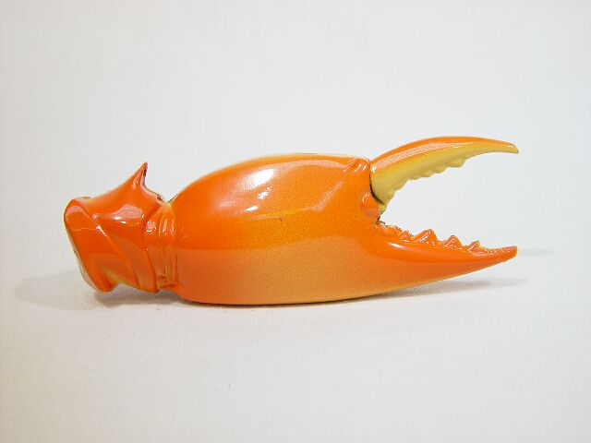
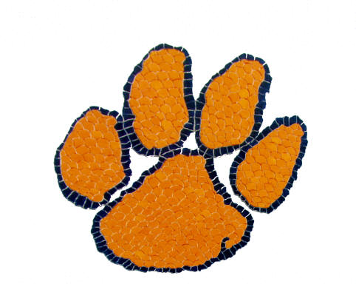
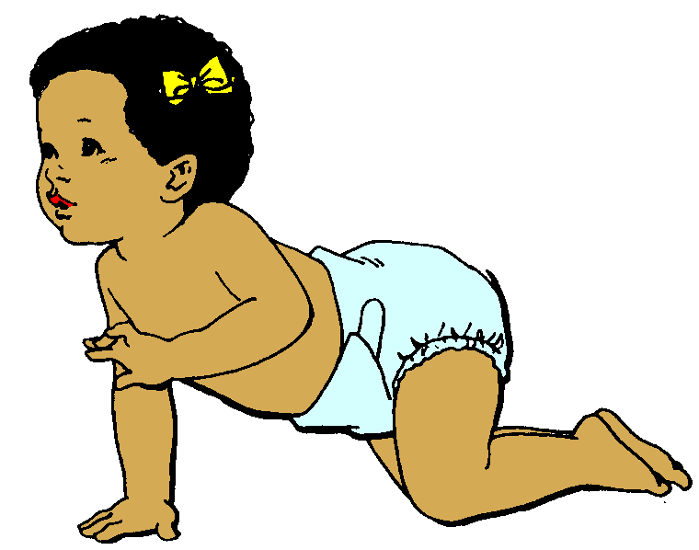
Put the correct word under each picture

prawn
draw
claw
dawn
pawn
lawn
paw
straw
crawl
fawn

Find the right word
- Crabs have them
- Cats, dogs and bears have them
- We can drink through this
- A young deer
- A baby learns to do this
- You can do this with a pencil
- A kind of sea creature
- When the sun comes up
- A chess piece that moves one square at a time
- Grass in your garden

