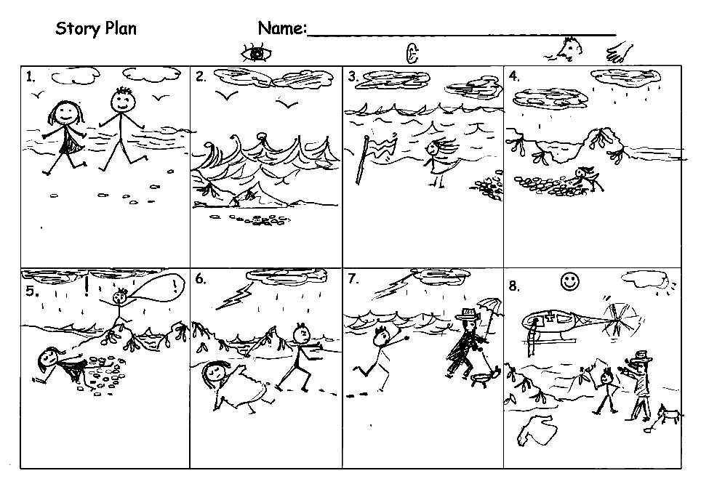
1.  _______and _________  were______________  __________________ | 2.  The w_______ were  __________ing. | 3.  The _________were  _________ing. | 4.  _________could smell  ____________________
5. !  Suddenly____________  ___________________  “_____________”  said______________. | 6.  First  ______________ | 7.  Then he____________  ____________________ | 8.  Soon_______________  _______felt _________. ☺

Jamie stopped and wiped her face. She was hot and thirsty. The beach was full of people. She could see children splashing about at the water’s edge and digging holes in the sand. As the waves came _________ing up the beach they filled the holes with water. Jamie watched as the children ran away __________ing.
Far away, Jamie could hear the sound of an ice-cream van. She suddenly wished she hadn’t run away from her older sister, Rosie. She __________all around but couldn’t see any sign of Rosie. Now what would she do? Jamie sniffed and a tear dropped from her eye.
On the Beach

Read the sentences.

Choose the strongest verbs from the boxes to write in the spaces.

Copy the sentences neatly into your book.

The wind ________ and the waves_____________ on the sand. | blew | whistled
The wind ________ and the waves_____________ on the sand. | fell | crashed
Seagulls _______________ and ________. | screeched | cried
Seagulls _______________ and ________. | flew down | swooped
The smell of seaweed ___________towards Jamie’s nose. | came | drifted
The pebbles made a ______________ noise under Jamie’s feet. | crunching | loud

*Now write 2 more sentences to describe what Jamie could hear, see, smell, taste, touch or feel.
Read you work and check for:
capital letters
full stops
verbs and sense
Using Strong Verbs

Choose the word you think is strongest to make an interesting sentence.
Write each sentence in your book .
The beach was | full | crowded | packed | with people.
Children were | shouting | laughing | screaming.
The weather was | hot | sunny | scorching.
Jamie felt | upset | worried | sad.
She began to | sob | cry | wail.
Jamie | called | shouted | yelled | Rosie’s name.
Jamie | ran | raced | dashed | along the beach.

Check:

Does each sentence have:
a capital letter to start ?

a strong verb ?

a full stop at the end ?

☺Well done!

