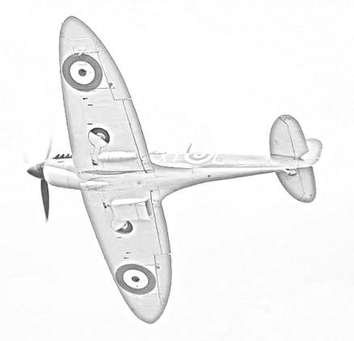
‘Blitz’ by Robert Westall

Read pages 9-17 and answer the following questions:
- Through whose eyes do you think the story is told?
- What were the games played in the Ruined City of Kor?
- What do you think a ‘dogfight’ is?

Read pages 18-25 and answer the following questions:
- The characters tried very hard to get the airman to safety, even though it was so dangerous. What would you have done? Explain your answer, giving at least three reasons.
- Why do you think the storyteller didn’t tell their dad about what really happened?

Read pages 27-35 and answer the following questions:
- Why do you think Maggie’s mum is acting so strangely?
- Can you predict how this story will end? Write an ending or draw and label a picture to show what you think will happen.

Read pages 36-45 and answer the following questions:
- Do you think Maggie’s dad made the right decision to return to the Army? Write a list of reasons why he should return to the Army, and reasons why he shouldn’t. How many can you think of?
- Write a letter from Maggie to her dad; include in it how Maggie feels about him being away and also write about how you think Maggie’s mum is now.

Read pages 47-56 and answer the following questions:
- Draw a mind map to show everything we know about the storyteller.
- What words or phrases does the author use to show how the storyteller dislikes the Home Guard?
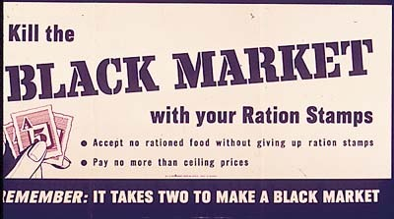
Read pages 57-66 and answer the following questions:
- Use one full page in your reading journal to create a poster warning against buying goods from the ‘black market.’

Read pages 69-79 and answer the following questions:
- The author is very clever at keeping the ending a secret, explain how you think he does this.
- Write a book review for this book.

