Capital Letters

LO: Recognise that proper nouns always have a capital letter.

Proper nouns are names of people. Write down five of your friends in the box.

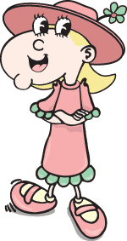

Proper nouns are names of places. Write down five places you have visited.

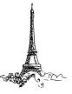

Proper nouns are days of the week and months of the year. Write down the month you were born and what day it is today.

