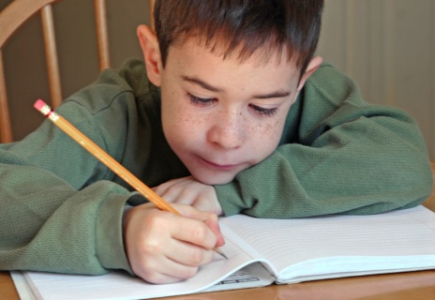
Clever Clauses
We use clauses to add extra interest to our sentences.
For example, a simple sentence might read.....
The lady walked down the stairs.
To make this more interesting we could put in a clause......
The lady walked down the stairs, whilst balancing an apple upon her head.
The lady walked down the stairs, whilst eating a ripe banana.
Another example....Here’s the simple version.
On Monday our teacher read a story.
Now we make it more interesting....
On Monday our teacher read us a story, meanwhile the class silently escaped.
On Monday our teacher read us a story, suddenly a gorilla jumped in through the open window.
Now try adding a clause to these simple sentences with your partner. Try saying your sentences to each other first, the write them down when you are happy with them. The first one is done for you.
- The cat sat on the mat.
The cat sat on the mat when she had finished her food.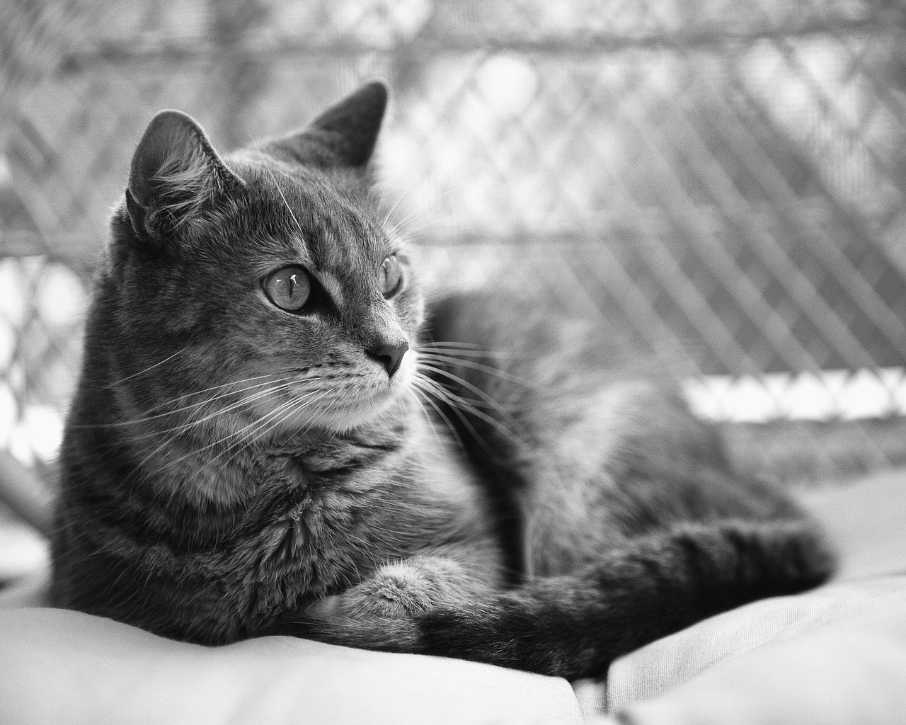
- The boy played football.
The boy played football __________________________________________

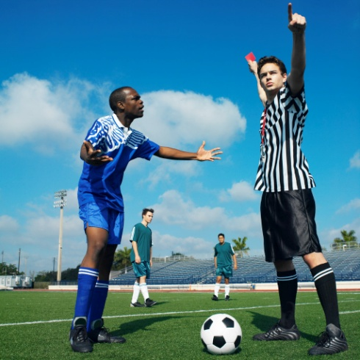

- The house was on fire.
The house was on fire____________________________________________



- When we got home we watched TV.
When we got home we watched TV__________________________________


- Now use the pictures to think of some of your own sentences with clauses. Write them on the back of this sheet.




