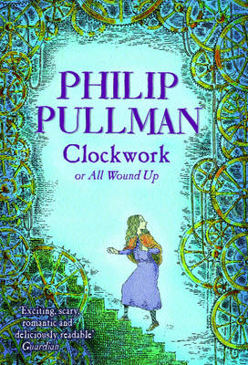
Clockwork or All Wound Up – Philip Pullman

Part One
p8 – What’s frightening about time?
p11 – What style/tone is it written in? Why?
P12 – Do you think Burgomaster is rude for forgetting Karl’s name? Why?
P13 – What’s a ‘figure?’
Why does he repeat the word ‘supposing?’
p14 – What makes the clock great?
p16 – What’s meant by an artistic temperament?
What do you think is wrong with Karl?
p17 – What’s the effect of the ellipse?
p18 – Explain what an optimist/pessimist is.
Which 2 actions show Karl is annoyed?
p21 – What do you think might happen?
Why does he begin with a question?
p22 – What’s a ‘commotion?’
Which adverbs describe the movement of the sledge?
p23 – What simile describes the Prince?
p24 – Which 3 places did they believe the soul was housed?
Where do you think a soul is?
p25 – Why is it a horrid image?
p26 – Who may have done this to Prince Otto? Why?
p27 – Explain the description of his eyes.
p29 – Which actions/grammar show the shock?
p30 – How do we know Fritz is scared?
p31 – Why might Fritz have run off?
p34 – how is Dr Kalmenius’ smile described?
p36 – what was Karl afraid of?
p38 – What do you feel about the figure?
p39 – Can you predict what might happen?
p40 – How does this compare to doing bad things? (gets out of control)
p43 – What significance does midnight often have?

Part Two
p47 – What’s an ‘heir?’
What’s happened to the story line?
p49 – What does she mean by her similes?
p51 – What issue may arise with a clockwork baby?
Why does the Prince do this?
p53 – How does the author feel about doctors?
p54 – Why’s Prince Otto so desperate to keep his son alive?
p55 – Why does he tell the Baron he wants his heart?
p56 – What’s the effect of the word ‘but?’
p58 – Why does the Baron sacrifice himself?
p60 – Why doesn’t Dr Kalmenius take the boy back?
p65 – Why is the chiming repeated?

Part Three
p69 – Why is Gretl so adamant?
p70 – What action shows Karl’s surprise?
p71 – What problems might this cause?
p72 – how is Karl changing?
p74 – Why has Fritz been drinking?
p75 – Why does Fritz wish he’d not told the story?
p76 – What does this paragraph imply?
p77 – Why is ‘have’ in italics?
p78 – What do you think has happened to the knight?
p79 – Why is thunder used in the simile?
p81 – Why does the author think Karl deserves this?
How is humour used to diffuse the horror of death?
p83 – Why is the word ‘wheel’ used?
p84 – What effect does the noise increasing have on the reader?
p85 – Why is Gretl so kind?
What might happen in the morning?
p91 – How did Gretl give him her heart?

