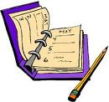
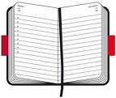
DIARY EXTRACT
I have included the date at the beginning.
I have described the important parts in a person’s life.

I have included informal words and phrases.

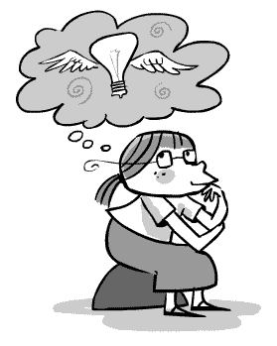
I have used adjectives to describe feelings and emotions.
I have written in the first person.
I have ended in a reflection.
I have written mainly in the past tense.
I have written in chronological order.
I have used time connectives.

