Using a Dictionary
Use your dictionary to find the correct spellings of these words.

mag . . . . . | cup . . . . . | pin . . . . . .
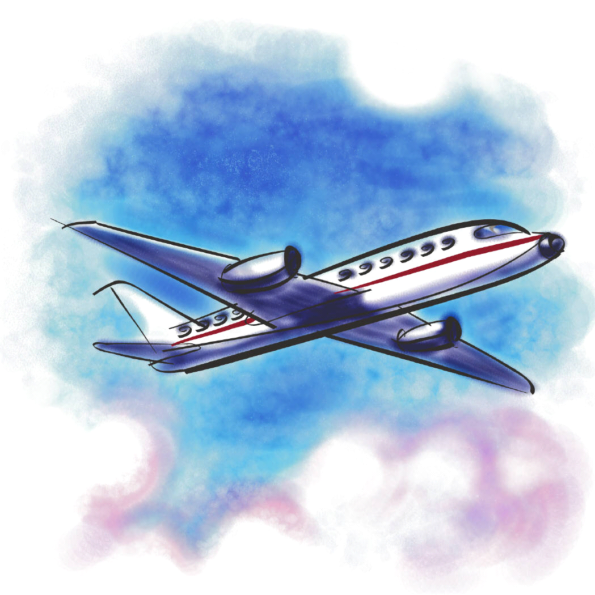  aer . . . . . . | ske . . . . . | bot . . .
kan . . . . . | gla . . . . | too . . . . . . .
dra . . . | vik . . . | mar . . . .

