Work Booklet –
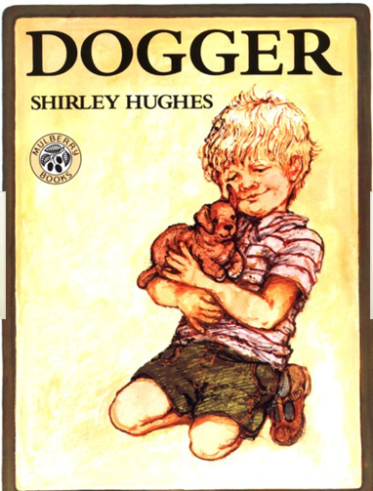

- Look carefully at the book cover, what do you think this book is going to be about? What kind of story do you expect it to be (i.e. crime, fantasy, sci-fi)? Why do you think this?

- What point of view is the story being told from (i.e. the narrator, the main character)? How do you know?

- Would you say that Dogger is Dave’s favourite toy? What words in the text makes you think that?

- Write a short description of your favourite toy.

- How do you think Dave felt when he realised he’d lost Dogger? Draw a picture of Dave and write his feelings around the outside.

- Design a ‘Lost’ poster for Dogger. You must draw a picture of Dogger and write a description of him. Don’t forget to add a contact number!

- Look closely at the Fathers’ faces in the race. Can you think of a few words to describe what they look like?!

- How do you think Dave felt when he saw Dogger again? How would you have felt if that was you?

- Do you think the girl who bought Dogger should be allowed to keep him? Why/why not? Explain your answers.

- Bella did something very nice for her brother. Would you do the same thing for your brother or sister?

- Can you write a review for this book? You should explain what you liked or disliked about the book and whether you would recommend this book to a friend.

