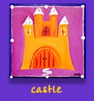
The Elements of a Fairy Tale Chart
- Special beginning and/or ending words - Once upon a time...and they lived happily ever after.
- Good character
- Evil character
- Royalty and/or a castle usually present
- Magic happens
Use this chart when being "element detectives"
with books from the genre of fairy tales
- Animals talk and come to the rescue
- Love is in the air
- Problem and a Solution
- Things often happen in "threes" or "sevens
Fairytale | Good Character | Evil Character | Animals | Royalty or castle | Magic | Love | 3’s or 7’s | Problem

