How to Fly a Hot Air Balloon

A hot air balloon consists of a basket, four big gas tanks, a burner and the balloon or ‘envelope’.

First, the pilot puts four nylon poles into sockets on top of the basket. Then she puts the burner on top of the poles. Next, she connects the cables to the burner frame. The cables also go under the basket in order to hold everything together.
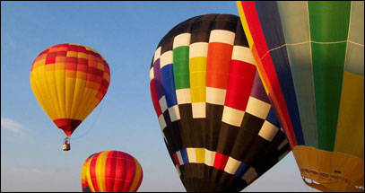
After this, she connects the hoses from the full gas tanks to the burner so that she can test it.

Next, two people hold the mouth of the balloon open while it is filled with cold air from the fan until it is quite fat and tight.

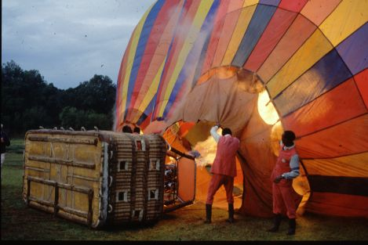
Now for the difficult bit. The pilot lies on the ground, half in the basket. She turns on the gas burner and points the flame into the ‘mouth’ of the balloon. This is so that the balloon slowly stands up.

When the pilot is ready to go, she heats up the air in the balloon a bit more. This results in the air in the balloon to be hot enough to get the balloon to rise off the ground.

