WALT: Identify features of non-fiction texts.

Front Cover | Contents Page | Subheading | Introduction
Photograph | Diagram | Index | Glossary

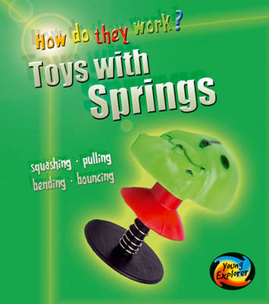
______________

Which toys have springs?……….. 2

How do they work? …………….. 4

What are they made of? ……….. 6

Toys through time ………………. 8

Index …………………………… 10

Glossary ………………………. 12

_______________

Some toys have a spring to make them move. In this book you will find out about the different kinds of toys that use springs and learn how they work.

1

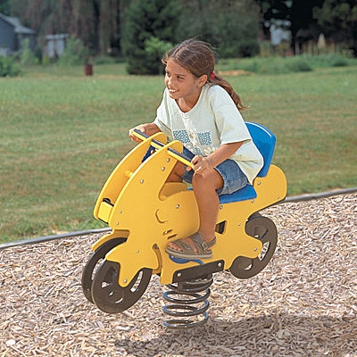
This toy has a spring so
it can move forwards and
backwards.
3

cut and stick activity
______________
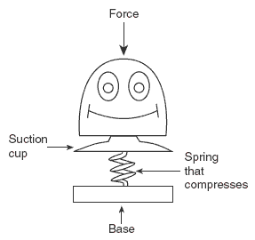
5
______________

Balance 4

Force 4, 5

Material 6

Museum 8

Spring 1, 3, 5, 6

Toy 1, 2, 3, 8,
___
______________

Balance - the ability to stay upright

Force - a push or a pull

Material - what something is made out of
Spring - An elastic device, such as a coil of wire, that regains its original shape after being compressed or extended.

___
Toys through time

The Jack-in-the-box is probably the best known old toy that uses a spring to make it move.

The toy seems to have originated in the 16th century when it was known as a Punch-box, which suggests that it may have been based on the puppet character that we know as Punch.
8

