Name _____________ Date _____________

Sounds

Fill in the first and last sounds of the words

_ o_ |  _a_
_a_ | _ a _
_ u _ | _u_
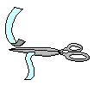_ u _ | _ o_

