Floppy’s Phonics Stage 3A “Queen’s Maid”
Word List
Read the words to your teacher.

fell | down | leg | Bill’s
Books | was | pain | Barry’s
upset | jobs | fun | Waiting
maid | Will | Queen | Down
Hatpin | Tut! | bow | Paid
polish | nails | now | All
rings | velvet | gown | Down
quick | vain | look | Good
bow | such | nod | are

Well done!!!

Tricky words

Queen ________________ _________________ ________________

quick ________________ _________________ ________________

down ________________ _________________ ________________

upset ________________ _________________ ________________

pain ________________ _________________ ________________

all ________________ _________________ ________________

jobs ________________ _________________ ________________

vain ________________ _________________ ________________

When you have read the words three times to your teacher you can colour in the box.

Queen
quick
down
upset
pain
all
jobs
vain

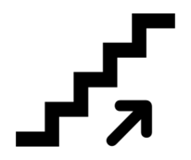
Sounds to think about:

ai

Say and write the words, match the pictures.
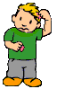

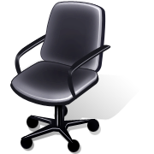
pain _____ ______ ______

Ow!
wait ______ ______ ______

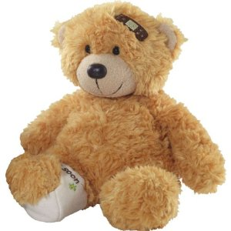
maid ______ ______ _______

afraid ______ ______ ______

hair ______ ______ ______
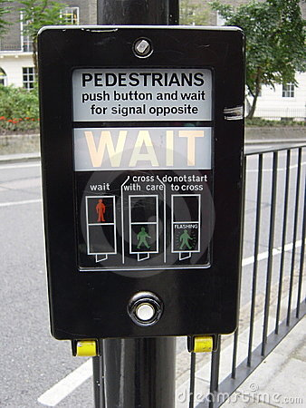
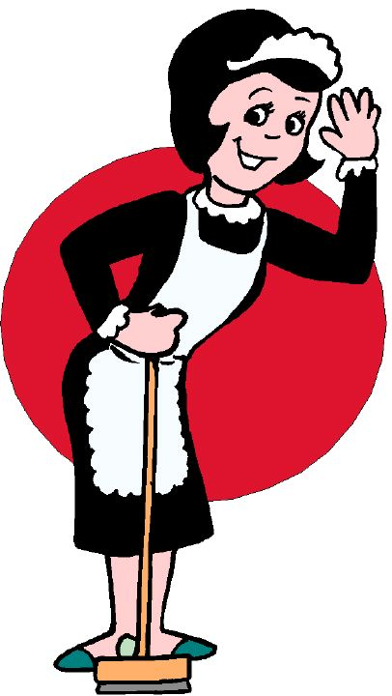

chair _______ ______ _______

fair ______ _______ ______

stair _____ _____ _____

Pages 1-6 Choose the correct word.

Mum fell up / down.

Mum was in pain / park.

Wilma was happy / upset.

Mum had to put her leg up / down.

Wilma and Wilf did all the hobs / jobs.

It was sad / fun waiting on Mum.

Draw Mum with her leg up. ( page 4).

I am in pain.

Pages 7- 15
Put the story in order.

Wilma had to bow.

Wilma was the maid.

Wilma sat down.

Wilma had to wait on the Queen.

Who said it?

I am in pain.
Page 4

_________________
Wow! What a lot of jobs.
Page 5

____________
Page 6
Mum is the Queen.

____________

Tut! Tut! You did not bow.
Page 9
__________
Will I get paid?
Page 11

____________

Pages 13
Get down my velvet gown.

_____________

Page 11. Draw the toys in the bath, add the bubbles.
What else was on the bath? Draw them too.
Draw the legs on the bath.
Draw Wilma with her jug of water.

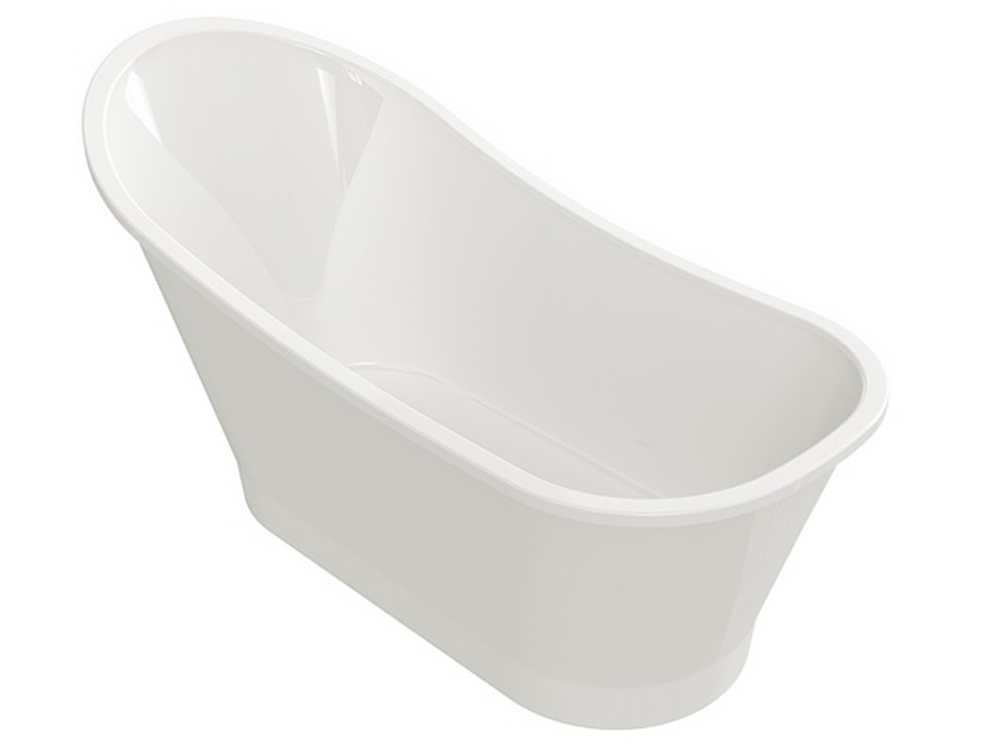

Draw the cat hiding.

Pages 9 - 12

Unscramble the sentences.

Wilma Queen was a maid to Hatpin.

Queen. wait had Wilma to the on ___________________________________________________________

Pain! such She is a

Page 11 What did Queen Hatpin and Wilma say? Draw Queen Hatpin and Wilma.

Look at the pictures.

Yes or No? What page tells you?

Wilma had to wait on the King. page ____

Queen Hatpin was vain. page ____

Wilma had to row. page ____

Mum had to put her arm up. page ____

Wilma had a nap. page ____

Wilma and Chip did all the jobs. page ____
...................................................................................................................................

Draw the jobs the children did. (page 5)

