Floppy’s Phonics Stage 3A “Toads in the Road”
Word List

Read the words to your teacher.

toad | road | hurt | you
burn | your | boat | yours
me | toads | car | turn
far | bar | they | coach
float | we | roads | jar
the | them | goats | load
are | boats | coat | that
oat | goat | this | star
loads | them | was | coats

Well done!!!

Tricky words

toad ________________ _________________ ________________

was ________________ _________________ ________________

the ________________ _________________ ________________

road ________________ _________________ ________________

hurt ________________ _________________ ________________

you ________________ _________________ ________________

loads ________________ _________________ ________________

rang ________________ _________________ ________________

When you have read the words three times to your teacher you can colour in the box.

toad
rang
was
you
loads
hurt
road
quick

Sounds to think about:

oa

Say and write the words, match the pictures.
Heavy
load

boat _____ ______ ______

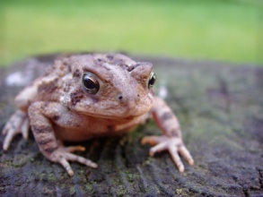
coat ______ ______ ______

float ______ ______ _______

goat ______ ______ ______

moat ______ ______ ______

load _______ ______ _______

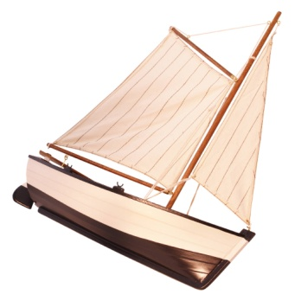
stoat ______ _______ ______

toad _____ _____ _____

Pages 1-6 Choose the correct word. Write the sentence.

A toad / goat was in the road. _______________________________

Dad put the toad up / down. ________________________________

Wilma / Dad ran to get Mum. ________________________________

Mum rang Wilma’s mum / dad. _______________________________

Dad / Gran got Biff and Chip. ________________________________

Draw Mum phoning Wilma’s mum. ( page 5).

Quick! Toads are on the road.

Pages 7- 10
Put the story in order.

Dad put the coat on.

They ran to get the toads.

Wilma’s mum had a big coat for dad.

A coach load of men turned up.

Who said it?

Toads! Turn back.
Page 10

_________________
We can pick up toads with you.
Page11

____________
Page 16
The toads will not get hurt now.

____________

Quick! Toads are on the road.
Page 5
__________
Loads of toads.
Page 3

____________

Pages 6
Quick! Toads are on the road.

_____________

Pages 10 - 15

Unscramble the sentences.

The toads. the men to ran up pick

road The shut. was
___________________________________________________________

Up. dug it Men

road. toad run in a put They the

Page 12 and 13 What did the men say? Draw the men.

Look at the pictures.

Yes or No? What page tells you?

Gran rang Wilma’s mum. page ____

Dad got Bill and Chip. page ____

Dad put the coat on. page ____

A coach load of women turned up. page ____

The road was open. page ____

They put a goat run in the road. page ____
...................................................................................................................................
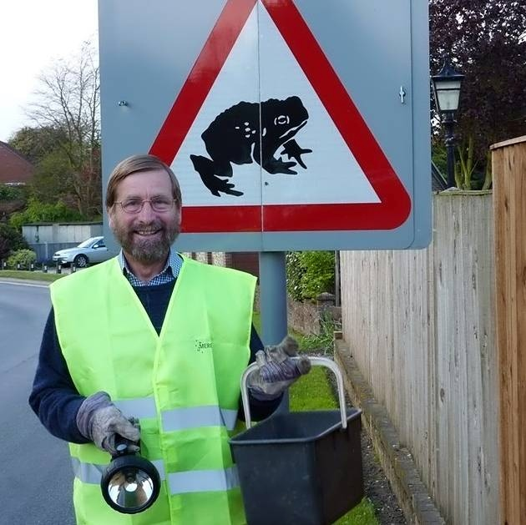
What do you think this man is trying to do?
Why is he wearing this jacket?
Why has he got a bucket and a torch?

Tell your teacher.

