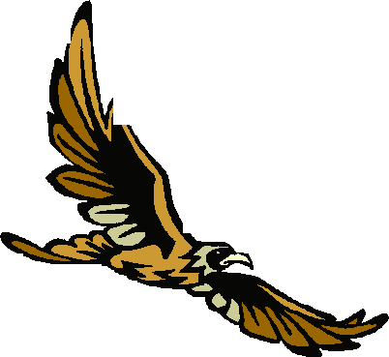
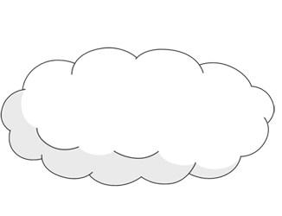
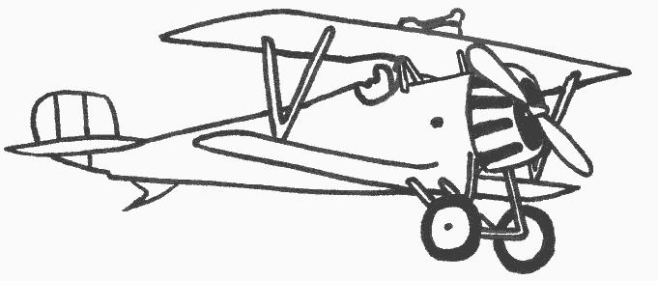





Name the collective noun for a group of birds.
FLYING HIGH – WONDERFUL WINGS 2002
AF2 True or False? Support with evidence.
a) Aeroplanes need to travel at great speed to become airborne?
b) birds need to move their wings to stop them falling.
c) a birds wings are a tiny bit arched on the tip.
d) large birds have to flap their wings more than small birds.
e) plane’s wings have to be designed differently to stop them falling from the sky.

AF3
a) Which words describe what the birds need to take off and stay in flight?
b) In ‘How Birds Fly’ which words tell us that the bird has to move it’s wings to fly?
c) What tells us that gliders are similar to planes?
d) Which word tells us that a plane is aerodynamic?
e) What propels a plane forward?

AF5
a) Is the writer an expert on this subject? Give reasons for your answer.
b) Why do you think the author has chosen the birds ‘sparrow’ and ‘seagull’ as examples?
c) Skim and scan to find something that’s not a fact but the author’s opinion.
d) Why do you think the author chose the title ‘Wonderful Wings’?
e) What does the word ‘thrust’ tell us about how the plane moves?

AF4
a) Name 2 ways the main body of text has been separated.
b) Why have the text and graphics been arranged in this way on page 5?
c) What is the significance of bullet points?
d) Why has the title been written in white with a black background?
e) look at the word ‘doesn’t’ in the 2nd paragraph and ‘bird’s’ in the 3rd paragraph. How have the apostrophes been used here?

For use with ‘Flying High’ SATs Booklet

