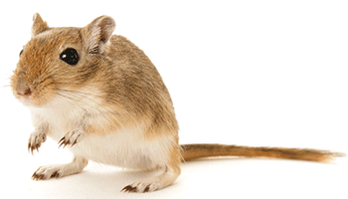
Looking after a pet gerbil.

There are many species of gerbil. The Mongolian gerbil is most often kept as a pet.

How to care for a gerbil.

Gerbils should never be kept alone and are happiest in small groups. You should handle a gerbil carefully to avoid any stress to the gerbil. Gerbils should be picked up by gently cupping them with two hands, and fully supporting their body. It is important to interact with your gerbils every day. You should never leave your gerbils unsupervised with another animal who may harm or frighten them. Finally, when caring for your gerbil it is most important that you should never pick up a gerbil by the tail, as this can really harm them.

A suitable home for a gerbil.

Provide your gerbils with a gerbilarium large enough to provide shelter, opportunities to dig and space to exercise. You should also provide adequate bedding and nesting material, because gerbils naturally like to build nests, so bedding material should be deep enough to allow your gerbils to dig and build their own nest. Provide your gerbil with a comfortable, dry, clean place to live, and keep your gerbils in a quiet place where they can rest undisturbed.

Gerbils like to have cardboard, paper, hay, empty toilet rolls, and egg containers to chew on. They also need a rough-surfaced object such as a stone to help wear down claws.

Don’t use a cage with metal bars as this can be dangerous for gerbils, also sawdust should not be used as it may cause breathing problems.

What a gerbil eats.
Gerbils must always have access to clean fresh water. You should feed your gerbils various grasses and a range of leaves and herbs. To keep a gerbil’s diet varied feed them fruit (pear, melon, apple, oranges) and vegetables (cucumber, carrot, and pumpkin). Do not give your gerbil grapes or rhubarb as these are poisonous to them. Gerbils love to hoard food in large stores; in the wild, gerbils may hoard up to 1.5kg of grain in one store! So don’t be surprised to find food around the cage.

Gerbils require care and attention, a specific diet and home. If you follow this advice for caring for a pet gerbil, it will be happy and healthy.

